**e-shopping**

1. Kanokwan Maneerat 542115002  
2. Nontra Mahachanont 542115026  
3. Worapun Wongkium 542115055

**User Requirement Specification**

Customer

|  |  |
| --- | --- |
| **No.** | **Requirement List** |
| URS 01 | The customer can login to the system by using username and password. |
| URS 03 | The customer can register to the system by provide the name, address, picture, username, and password. |
| URS 04 | The customer can update their information. |
| URS 05 | The customer can log out from the system. |
| URS 08 | The customer can browse the catalog. |
| URS 09 | The customer can search for the product name. |
| URS 10 | The customer can choose the product to shopping cart as many products as he/she wants. |
| URS 11 | The customer can see the summary of his/her shopping cart. |
| URS 12 | The customer can check out the shopping cart. |
| URS 13 | The customer can view his/her history of shopping cart consists of cart ID, total price, checkout status, and date. |

Administrator

|  |  |
| --- | --- |
| **No.** | **Requirement List** |
| URS 06 | The administrator can add product and provide details of the product which contain product name, product description, and picture of product. |
| URS 07 | The administrator can see the shopping history of all customers in his/her page. |
| URS 02 | The administrator can login to the system by using username and password. |

**System Requirement Specification**

URS 01: The customer can login to the system by using username and password.

|  |  |
| --- | --- |
| **No.** | **Requirement List** |
| SRS 01 | The system provides the UI which receive the username and password to login. |
| SRS 02 | The system validates the username and password. |
| SRS 03 | The system display error message “Incorrect username or password”. |
| SRS 04 | The system shows an error message “Can’t leave this empty.” |

URS 02: The administrator can login to the system by using username and password.

|  |  |
| --- | --- |
| **No.** | **Requirement List** |
| SRS 05 | The system provides the UI which receive the admin name and password to login. |
| SRS 06 | The system validates the admin name and password. |
| SRS 03 | The system display error message “Incorrect username or password”. |
| SRS 04 | The system shows an error message “Can’t leave this empty.” |

URS 03: The customer can register to the system by provide the name, address, picture, username, and password.

|  |  |
| --- | --- |
| **No.** | **Requirement List** |
| SRS 07 | The system provides the UI which receive the name, address, picture, username, and password for the registration. |
| SRS 08 | The system can check the length of username format which contain only characters has the maximum length is twenty. |
| SRS 09 | The system can check the username format; the username format must be a unique username. |
| SRS 10 | The system can check the length of the password format, the maximum length of password must be 4-20 letters. |
| SRS 11 | The system shall retrieve the existing customer information to the data from username. |
| SRS 12 | The system shall provide the successful registration page. |
| SRS 13 | The system shall display error message is “This username is already exist”. |
| SRS 14 | The system shall display error message is “Password length should be 4-20 letters” |
| SRS 15 | The system shall display error message is “The name must be only characters” |
| SRS 16 | The system shall display error message is “The username length should not over 20” |
| SRS 17 | The system shall display error message is “These passwords doesn’t match. Try again” |
| SRS 18 | The system shall display error message is “The picture should be JPEG image (.jpg)” |
| SRS 04 | The system shows an error message “Can’t leave this empty.” |

URS 04: The customer can update their information.

|  |  |
| --- | --- |
| **No.** | **Requirement List** |
| SRS 19 | The system provides the UI which receive the name, address, picture, and password to edit the information. |
| SRS 10 | The system can check the length of the password format, the maximum length of password must be 4-20 letters. |
| SRS 11 | The system shall retrieve the existing customer information to the data from username. |
| SRS 12 | The system shall provide the successful registration page. |
| SRS 13 | The system shall display error message is “This username is already exist”. |
| SRS 14 | The system shall display error message is “Password length should be 4-20 letters” |
| SRS 14 | The system shall display error message is “Password length should be 4-20 letters” |
| SRS 15 | The system shall display error message is “The name must be only characters” |
| SRS 16 | The system shall display error message is “The username length should not over 20” |
| SRS 17 | The system shall display error message is “These passwords doesn’t match. Try again” |
| SRS 18 | The system shall display error message is “The picture should be JPEG image (.jpg)” |
| SRS 04 | The system shows an error message “Can’t leave this empty.” |

URS 05: The customer can log out from the system.

|  |  |
| --- | --- |
| **No.** | **Requirement List** |
| SRS 20 | The system provides the logout button after login at every page. |
| SRS 21 | The system should clear user’s session. |

URS 06: The administrator can add product and provide details of the product which contain product name, product description, and picture of product.

|  |  |
| --- | --- |
| **No.** | **Requirement List** |
| SRS 22 | The system shall add the product information which administrator provide into database. |
| SRS 15 | The system shall display error message is “The product name must be only characters” |
| SRS 23 | The system shall display error message is “The product id length should have 6 digits” |
| SRS 18 | The system shall display error message is “The picture should be JPEG image (.jpg)” |

URS 07: The administrator can see the shopping history of all customers in his/her page.

|  |  |
| --- | --- |
| **No.** | **Requirement List** |
| SRS 24 | The system shall query the all customer’s shopping history from database. |
| SRS 25 | The system shall display all customer’s shopping history. |

URS 08: The customer can browse the catalog.

|  |  |
| --- | --- |
| **No.** | **Requirement List** |
| SRS 26 | The system provides the catalog UI to display catalogs. |
| SRS 27 | The system shall query the product list from database. |

URS 09: The customer can search for the product name.

|  |  |
| --- | --- |
| **No.** | **Requirement List** |
| SRS 28 | The system provides the search box in every page. |
| SRS 29 | The system provides the UI for showing the list of searched product. |
| SRS 30 | The system shall match the search’s keywords with product’s keywords. |
| SRS 31 | The system shall display error message “No matched product found”. |

URS 10: The customer can choose the product to shopping cart as many products as he/she wants.

|  |  |
| --- | --- |
| **No.** | **Requirement List** |
| SRS 32 | The system provides the UI to show the product name, picture, and price. |
| SRS 33 | The system can add product which customer select to the cart into database. |
| SRS 34 | The system shows the error message “This product is now unavailable” |

URS 11: The customer can see the summary of his/her shopping cart.

|  |  |
| --- | --- |
| **No.** | **Requirement List** |
| SRS 35 | The system shall display the list of product which customer chooses. |
| SRS 36 | The system shall query the product that customer chooses from database. |
| SRS 37 | The system shall calculate the total price of all products in shopping cart. |
| SRS 38 | The system shall display the total price of all product that customer choose. |

URS 12: The customer can check out the shopping cart.

|  |  |
| --- | --- |
| **No.** | **Requirement List** |
| SRS 39 | The system shall provide the payment option UI for customer to select. |
| SRS 40 | The system shall provide the buying history UI for customer to fill. |
| SRS 41 | The system shall connect to the each payment system, which consist of bank system for money transfer, credit card and PayPal. |
| SRS 42 | The system shall saving check out status to the database. |
| SRS 43 | The system shall saving payment option to the database. |
| SRS 44 | The system shall saving buying history to the database. |

URS 13: The customer can view his/her history of shopping cart consists of cart ID, total price, checkout status, and date.

|  |  |
| --- | --- |
| **No.** | **Requirement List** |
| SRS 45 | The system shall query the customer’s shopping history from database. |
| SRS 46 | The system shall display customer’s shopping history. |

**Class Diagram**

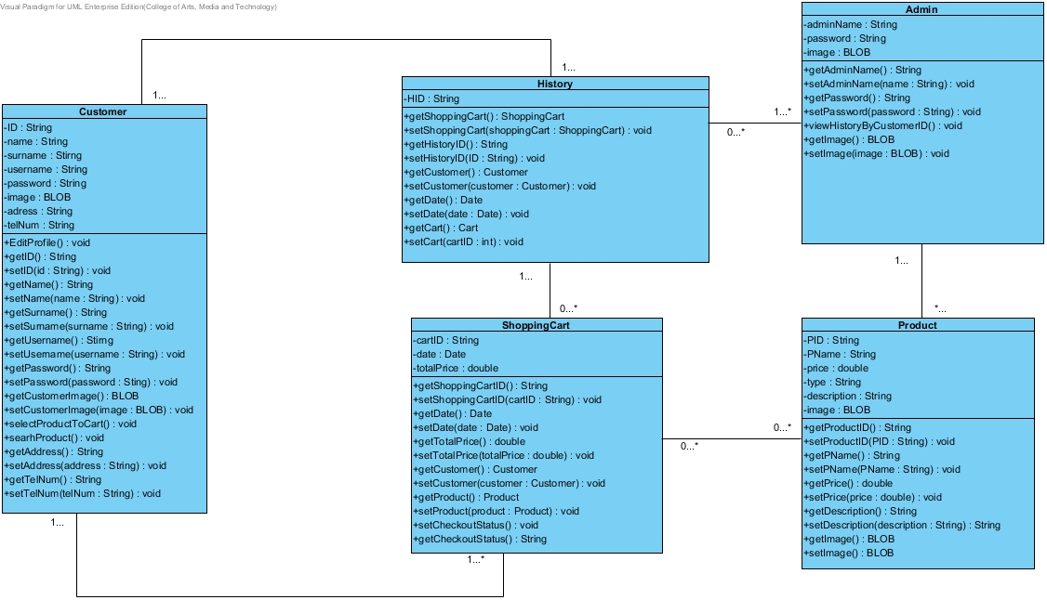

**Admin MVC**

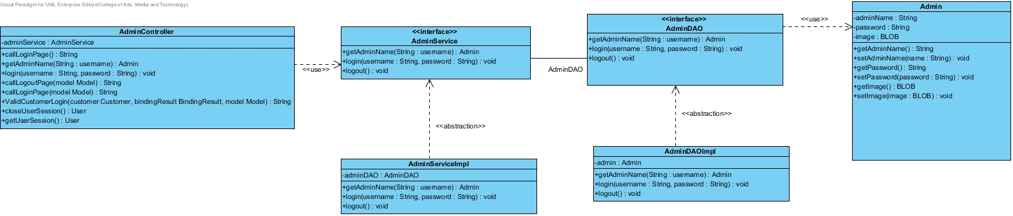

**Customer MVC**

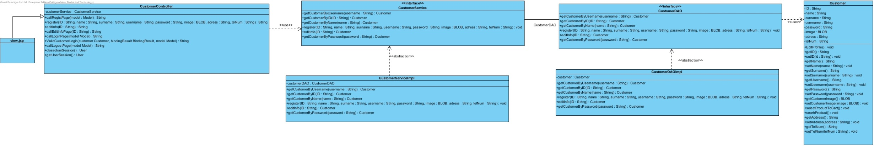

**History MVC**

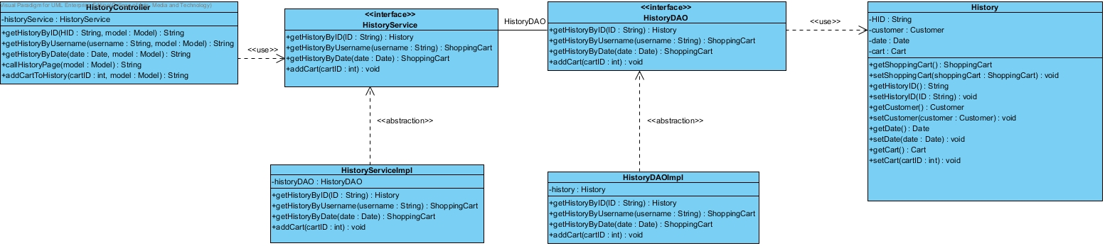

**Product MVC**

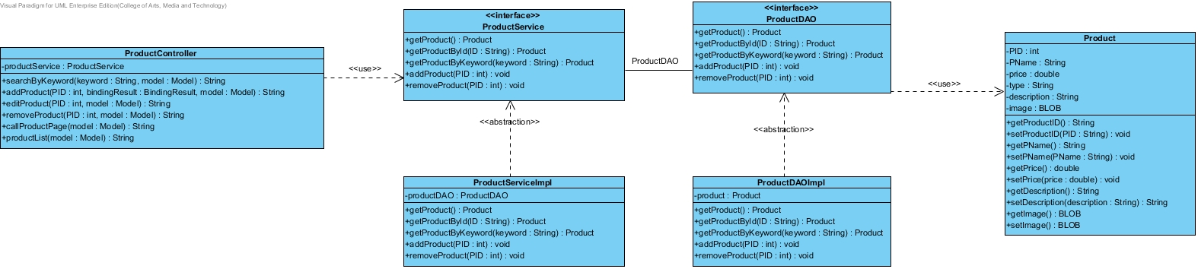

**Shopping Cart MVC**

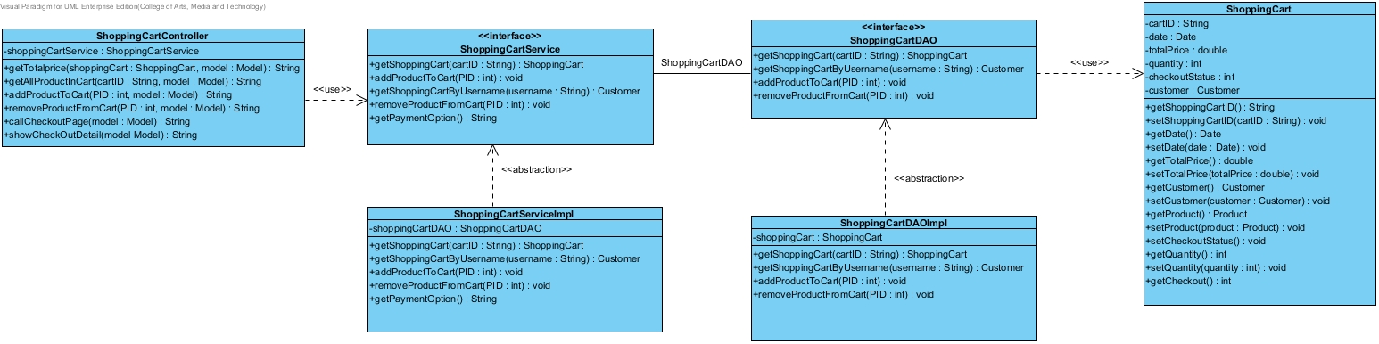

**Sequence Diagram**

Customer Login

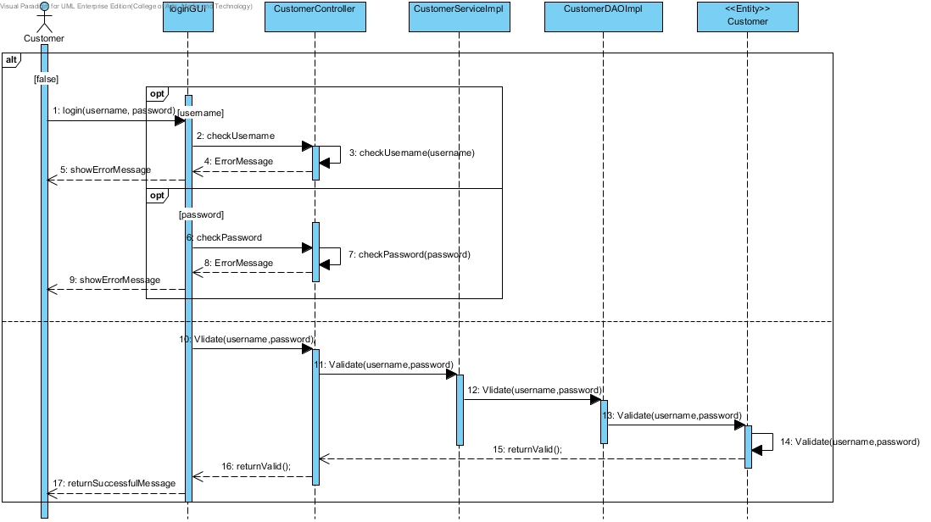

Customer Register

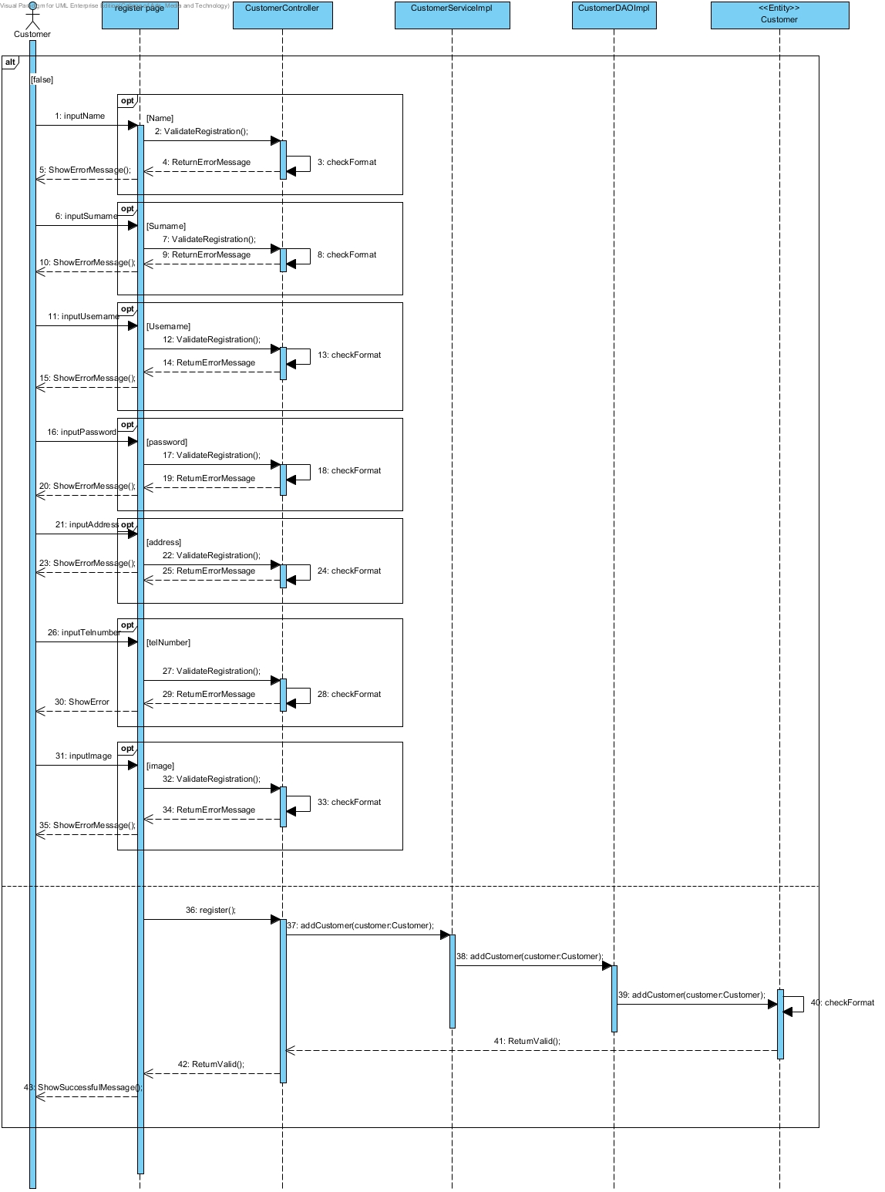

**Customer update information**

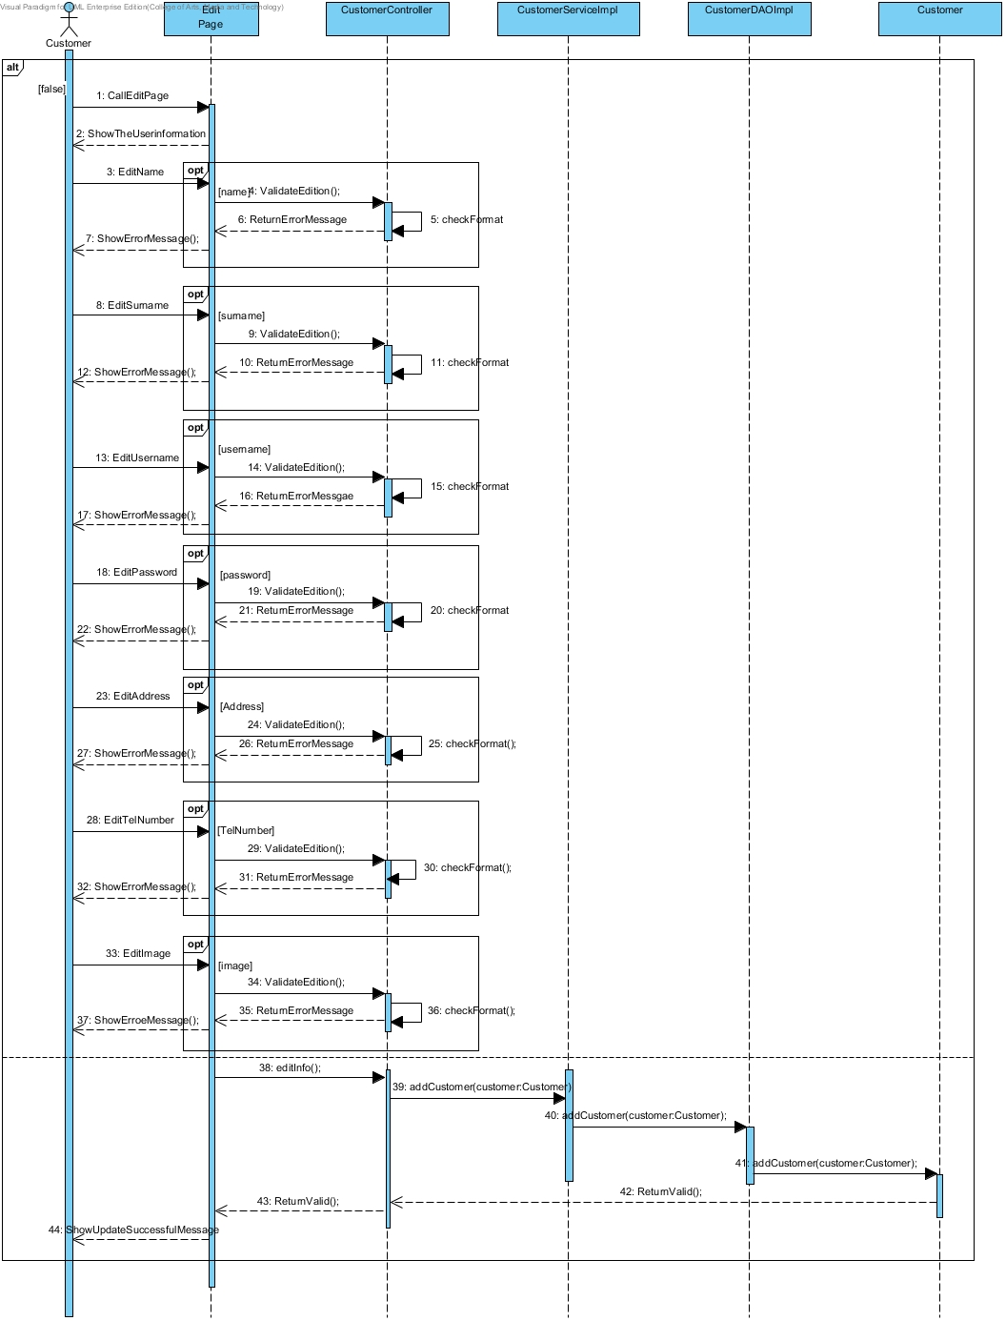**Search Product**

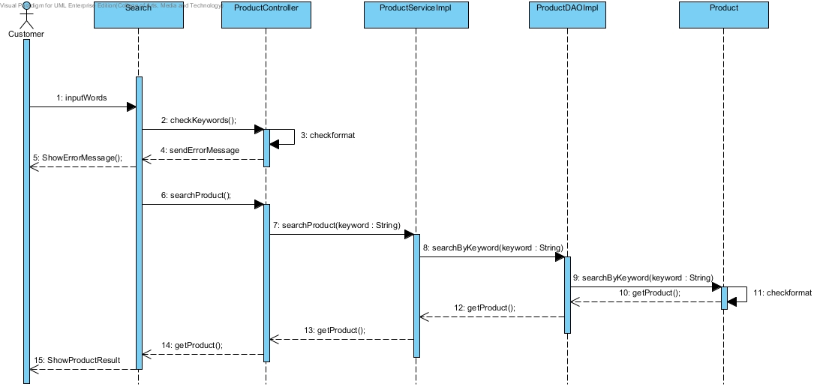

**Checkout Product**

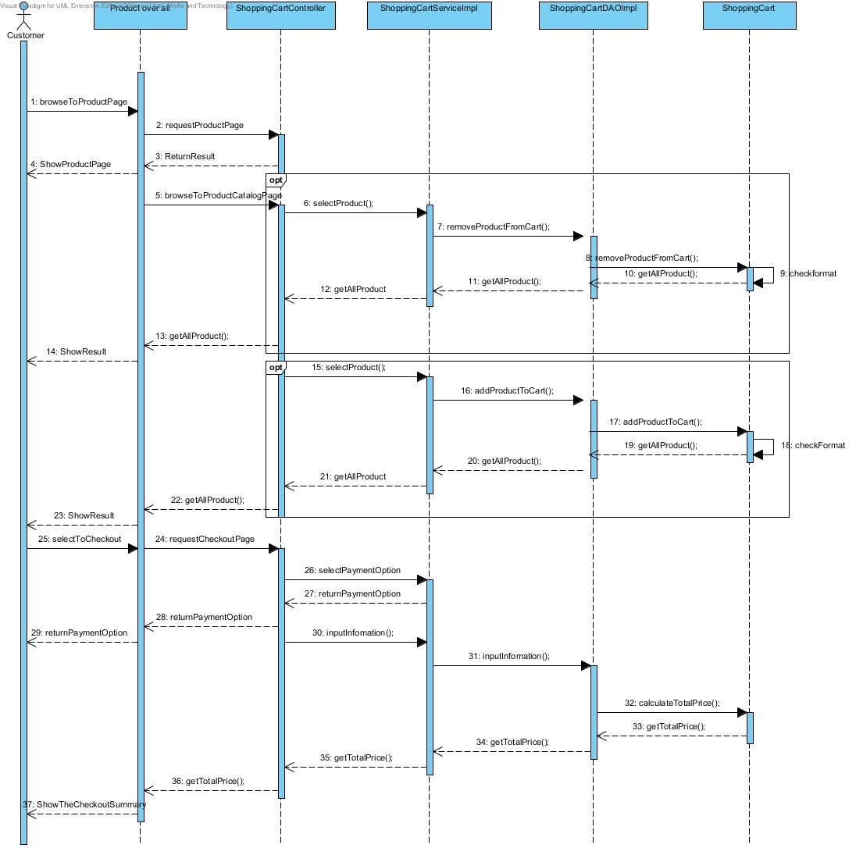

**Select Product to shopping cart**

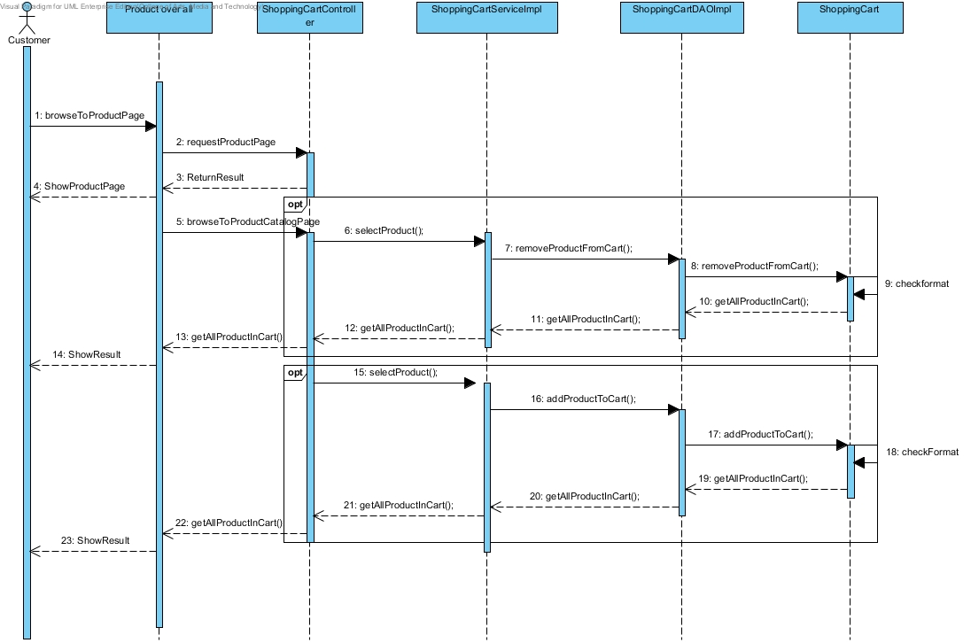

**View history**

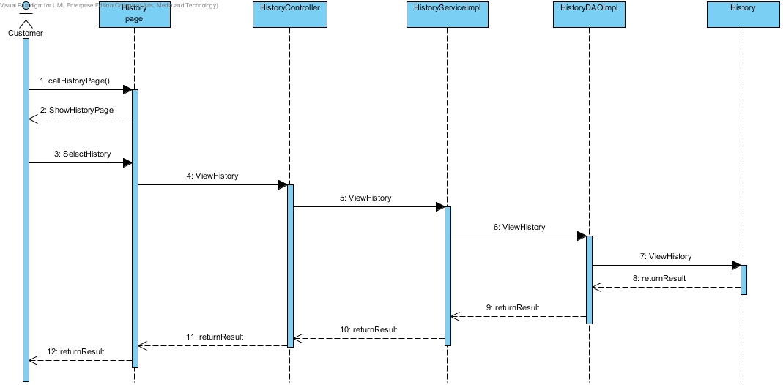

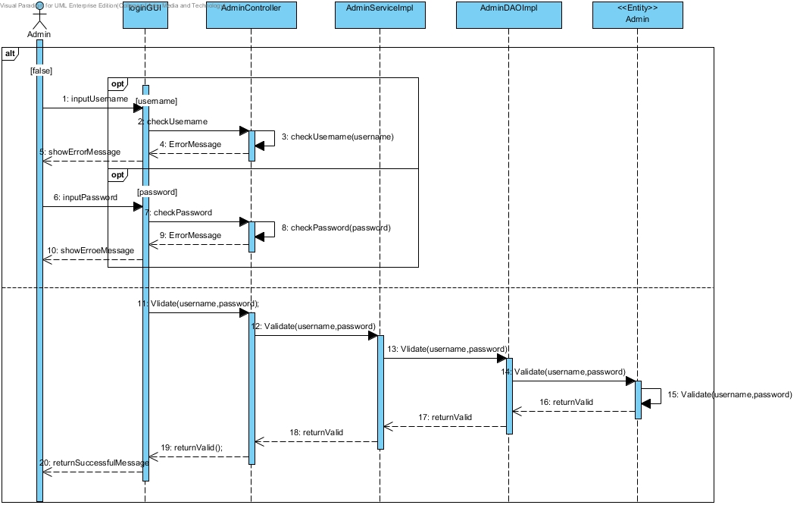**Admin Login**

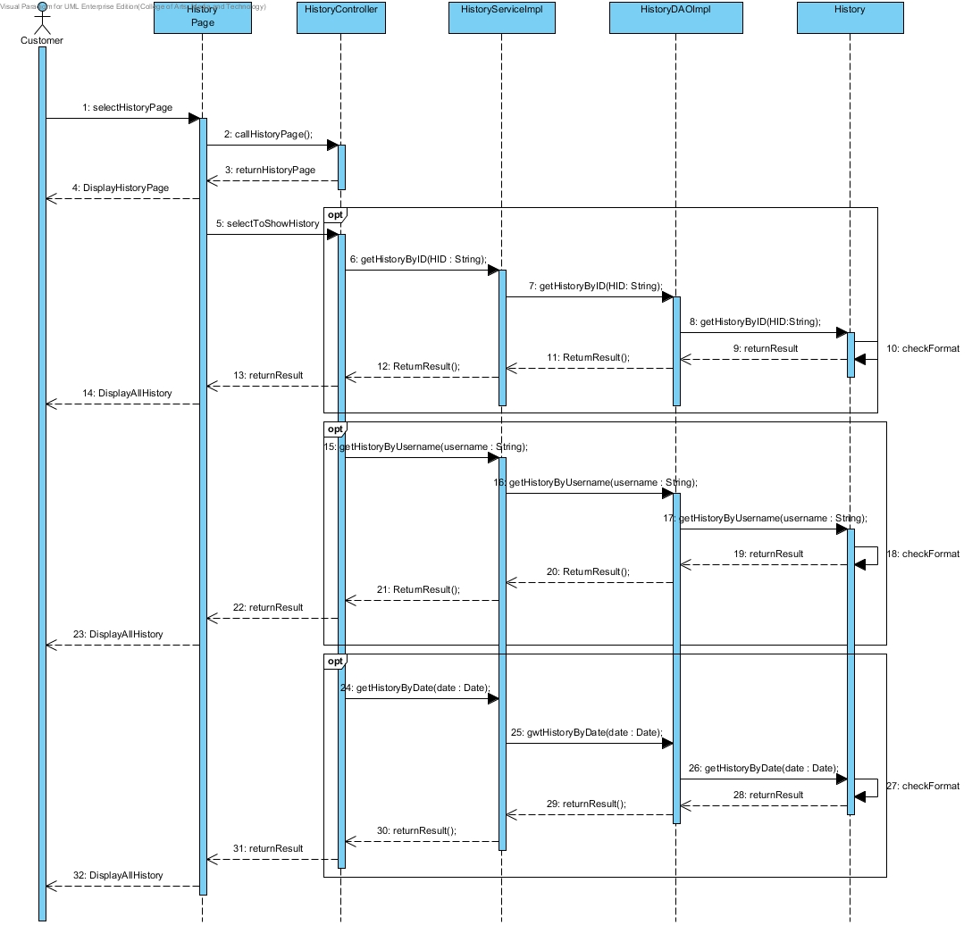**View history by admin**

**Edit product by admin**

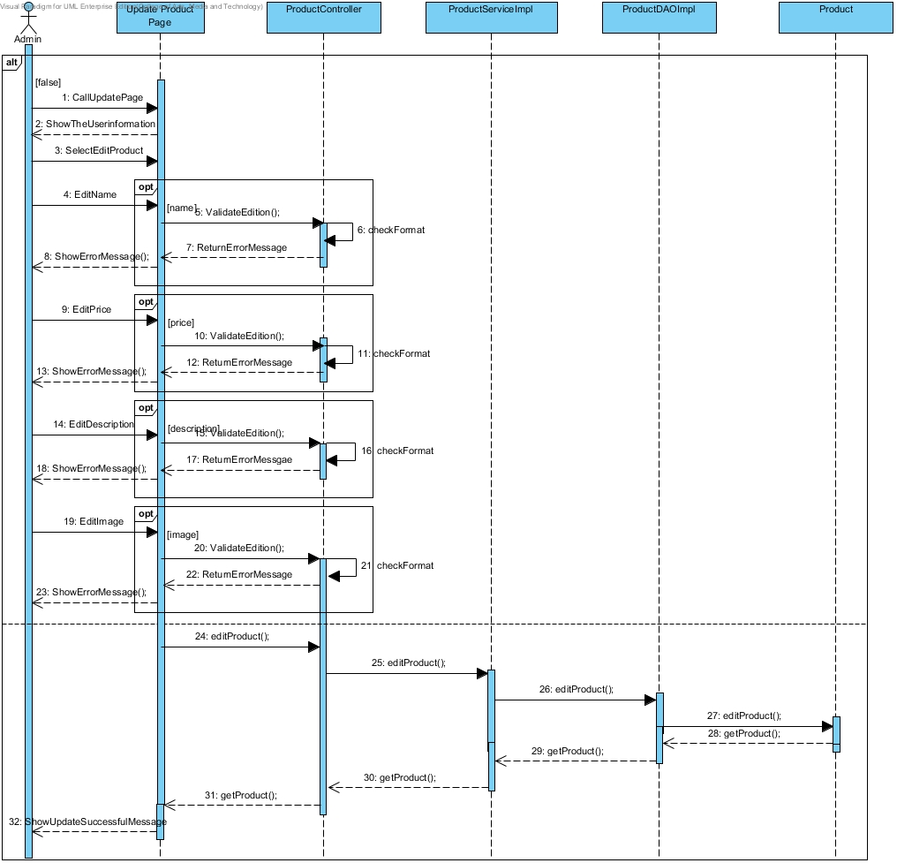

**Add product by admin**

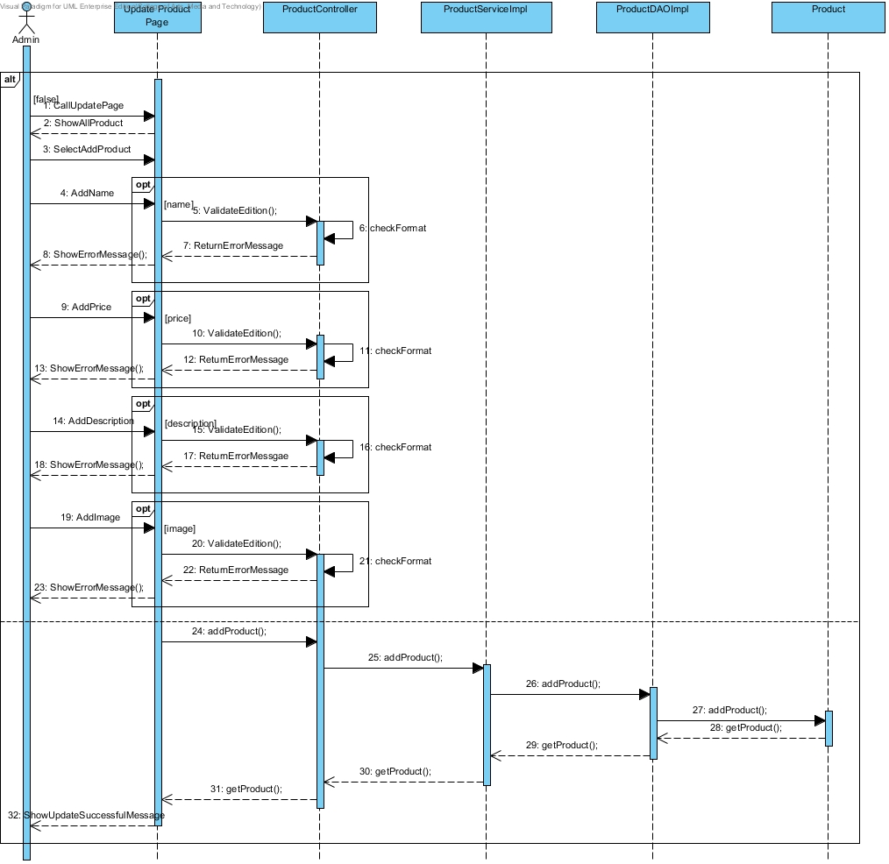

**Remove product by admin**

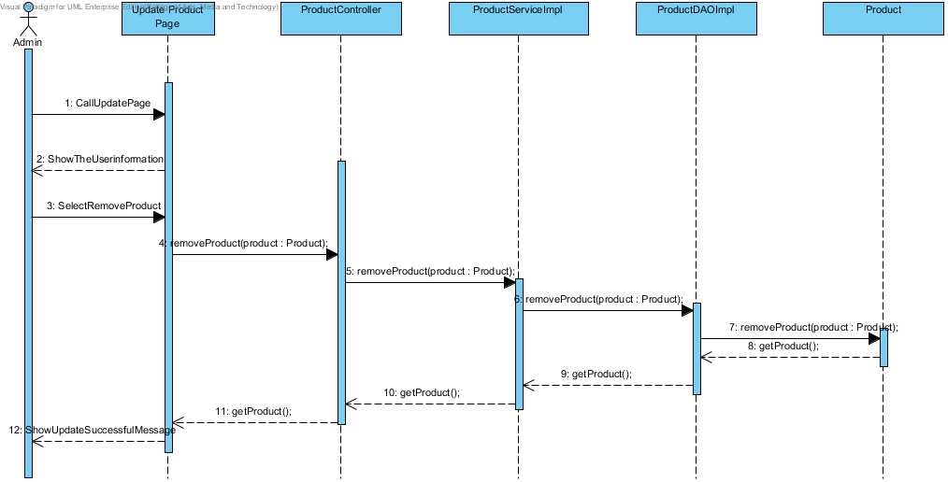

**Logout**

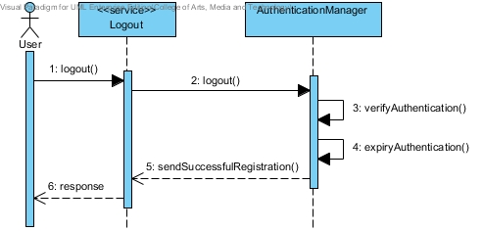

**View shopping cart summary**

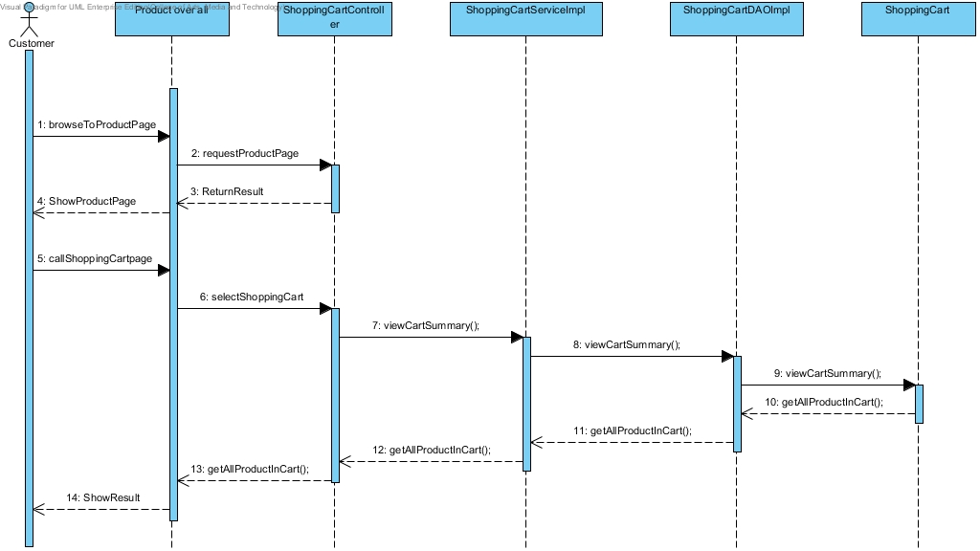

**Method Design**

**Class Name**: ProductController

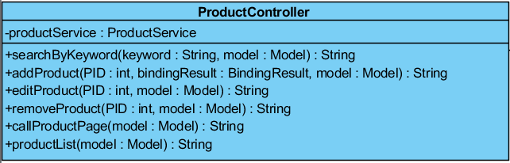

**Method:**

|  |  |  |  |
| --- | --- | --- | --- |
| **ID** | **Name** | **Description** | **Remark** |
| 1 | SearchByKeyword() | This method uses for searching the product by using product’s keyword from database. | **Return Type**: String  **Parameters:** keyword, model |
| 2 | addProduct() | This method uses for adding the product into database. | **Return Type**: String  **Parameters:** PID, bindingResult, model |
| 3 | editProduct() | This method uses for editing the details of the product from database. | **Return Type**: String  **Parameters:** PID, model |
| 4 | removeProduct() | This method uses for removing the product from database. | **Return Type**: String  **Parameters:** PID, model |
| 5 | callProductPage() | This method uses for calling the product page from database. | **Return Type**: String  **Parameters:** model |
| 6 | productList() | This method uses for showing the entire of product list from database. | **Return Type**: String  **Parameters:** model |

**Class Name**: ProductService

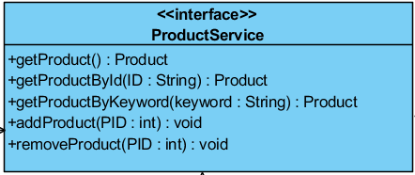

**Method:**

|  |  |  |  |
| --- | --- | --- | --- |
| **ID** | **Name** | **Description** | **Remark** |
| 1 | getProduct() | This method uses for getting the product from database. | **Return Type**: Product  **Parameters:** None |
| 2 | getProductByid() | This method uses for getting the product by using product’s id from database. | **Return Type**: Product  **Parameters:** ID |
| 3 | getProductByKeyword() | This method uses for getting the product by using product’s keyword from database. | **Return Type**: Product  **Parameters:** keyword |
| 4 | addProduct() | This method uses for adding the product and details into database. | **Return Type**: void  **Parameters:** PID |
| 5 | removeProduct() | This method uses for removing the product and details from database. | **Return Type**: void  **Parameters:** PID |

**Class Name**: ProductServiceImpl

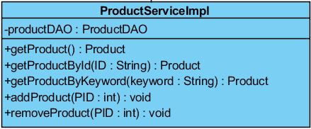

**Method:**

|  |  |  |  |
| --- | --- | --- | --- |
| **ID** | **Name** | **Description** | **Remark** |
| 1 | getProduct() | This method uses for getting the product from database. | **Return Type**: Product  **Parameters:** None |
| 2 | getProductByid() | This method uses for getting the product by using product’s id from database. | **Return Type**: Product  **Parameters:** ID |
| 3 | getProductByKeyword() | This method uses for getting the product by using product’s keyword from database. | **Return Type**: Product  **Parameters:** keyword |
| 4 | addProduct() | This method uses for adding the product and details into database. | **Return Type**: void  **Parameters:** PID |
| 5 | removeProduct() | This method uses for removing the product and details from database. | **Return Type**: void  **Parameters:** PID |

**Class Name**: ProductDAO

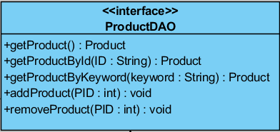

**Method:**

|  |  |  |  |
| --- | --- | --- | --- |
| **ID** | **Name** | **Description** | **Remark** |
| 1 | getProduct() | This method uses for getting the product from database. | **Return Type**: Product  **Parameters:** None |
| 2 | getProductByid() | This method uses for getting the product by using product’s id from database. | **Return Type**: Product  **Parameters:** ID |
| 3 | getProductByKeyword() | This method uses for getting the product by using product’s keyword from database. | **Return Type**: Product  **Parameters:** keyword |
| 4 | addProduct() | This method uses for adding the product and details into database. | **Return Type**: void  **Parameters:** PID |
| 5 | removeProduct() | This method uses for removing the product and details from database. | **Return Type**: void  **Parameters:** PID |

**Class Name**: ProductDAOImpl

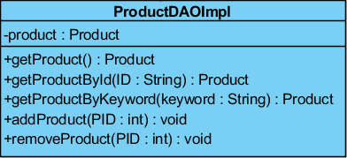

**Method:**

|  |  |  |  |
| --- | --- | --- | --- |
| **ID** | **Name** | **Description** | **Remark** |
| 1 | getProduct() | This method uses for getting the product from database. | **Return Type**: Product  **Parameters:** None |
| 2 | getProductByid() | This method uses for getting the product by using product’s id from database. | **Return Type**: Product  **Parameters:** ID |
| 3 | getProductByKeyword() | This method uses for getting the product by using product’s keyword from database. | **Return Type**: Product  **Parameters:** keyword |
| 4 | addProduct() | This method uses for adding the product and details into database. | **Return Type**: void  **Parameters:** PID |
| 5 | removeProduct() | This method uses for removing the product and details from database. | **Return Type**: void  **Parameters:** PID |

**Class Name**: ShoppingCart

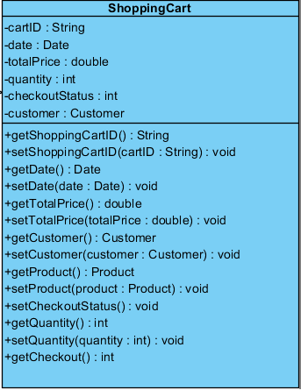

**Method:**

|  |  |  |  |
| --- | --- | --- | --- |
| **ID** | **Name** | **Description** | **Remark** |
| 1 | setCheckoutStatus() | This method uses for setting the checkout status to database. | **Return Type**: void  **Parameters:** None |
| 2 | getCheckout() | This method uses for getting the checkout status from database. | **Return Type**: Int  **Parameters:** None |

**Class Name**: ShoppingCartController

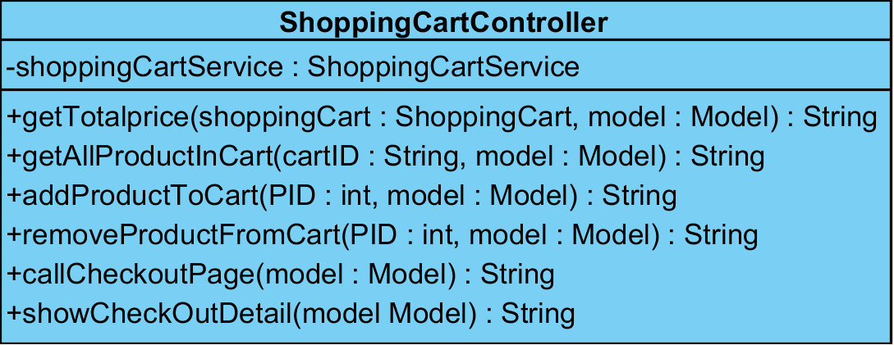

**Method:**

|  |  |  |  |
| --- | --- | --- | --- |
| **ID** | **Name** | **Description** | **Remark** |
| 1 | getTotalPrice() | This method uses for getting the total price of transaction from database. | **Return Type**: String  **Parameters:** shoppingCart, model |
| 2 | getAllProductInCart() | This method uses for getting the entire of product in shopping cart from database. | **Return Type**: String  **Parameters:** cartID, model |
| 3 | addProductToCart() | This method uses for adding the product into shopping cart. | **Return Type**: String  **Parameters:** PID, model |
| 4 | removeProductFromCart() | This method uses for removing the product and details from shopping cart. | **Return Type**: String  **Parameters:** PID, model |
| 5 | callCheckoutPage() | This method uses for calling the checkout page from database. | **Return Type**: String  **Parameters:** model |
| 6 | showCheckOutDeatail() | This method uses for showing the checkout’s details from database. | **Return Type**: String  **Parameters:** model |

**Class Name**: ShoppingCartService

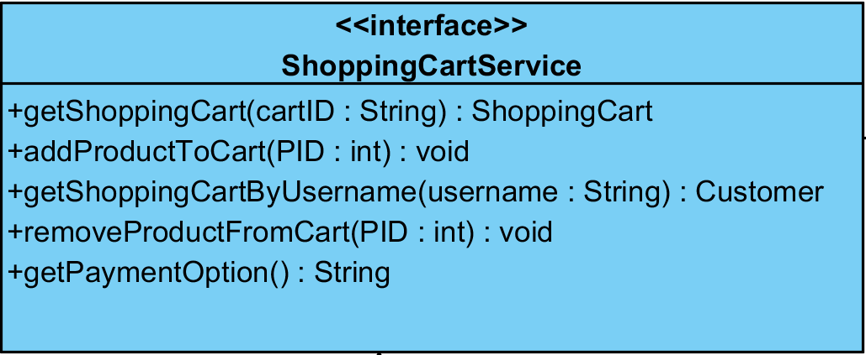

**Method:**

|  |  |  |  |
| --- | --- | --- | --- |
| **ID** | **Name** | **Description** | **Remark** |
| 1 | getShoppingCart() | This method uses for getting the shopping cart from database. | **Return Type**: ShoppingCart  **Parameters:** cartID |
| 2 | getShoppingCartByUsername() | This method uses for getting the shopping cart by using customer’s username from database. | **Return Type**: Customer  **Parameters:** username |
| 3 | addProductToCart() | This method uses for adding the product and quantity into shopping cart. | **Return Type**: void  **Parameters:** PID |
| 4 | removeProductFromCart() | This method uses for removing the product and quantity from shopping cart. | **Return Type**: void  **Parameters:** PID |
| 5 | getPaymentOption() | This method uses for getting the payment option from database. | **Return Type**: String  **Parameters:** None |

**Class Name**: ShoppingCartServiceImpl

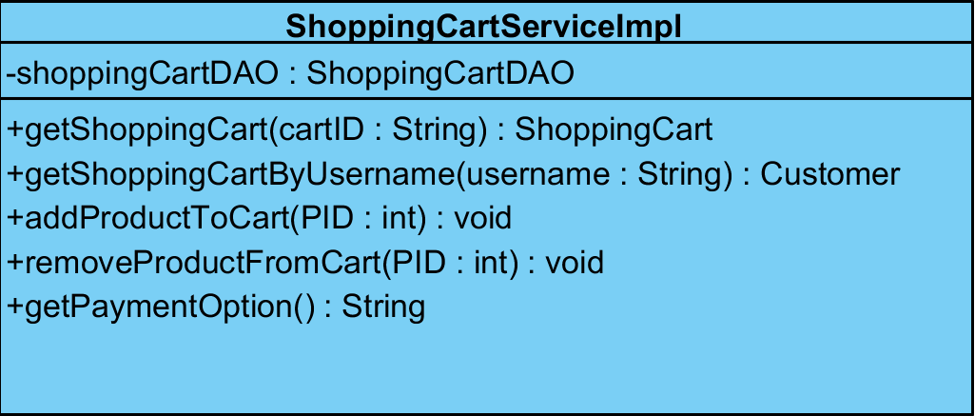

**Method:**

|  |  |  |  |
| --- | --- | --- | --- |
| **ID** | **Name** | **Description** | **Remark** |
| 1 | getShoppingCart() | This method uses for getting the shopping cart from database. | **Return Type**: ShoppingCart  **Parameters:** cartID |
| 2 | getShoppingCartByUsername() | This method uses for getting the shopping cart by using customer’s username from database. | **Return Type**: Customer  **Parameters:** username |
| 3 | addProductToCart() | This method uses for adding the product and quantity into shopping cart. | **Return Type**: void  **Parameters:** PID |
| 4 | removeProductFromCart() | This method uses for removing the product and quantity from shopping cart. | **Return Type**: void  **Parameters:** PID |
| 5 | getPaymentOption() | This method uses for getting the payment option from database. | **Return Type**: String  **Parameters:** None |

**Class Name**: ShoppingCartDAOImpl

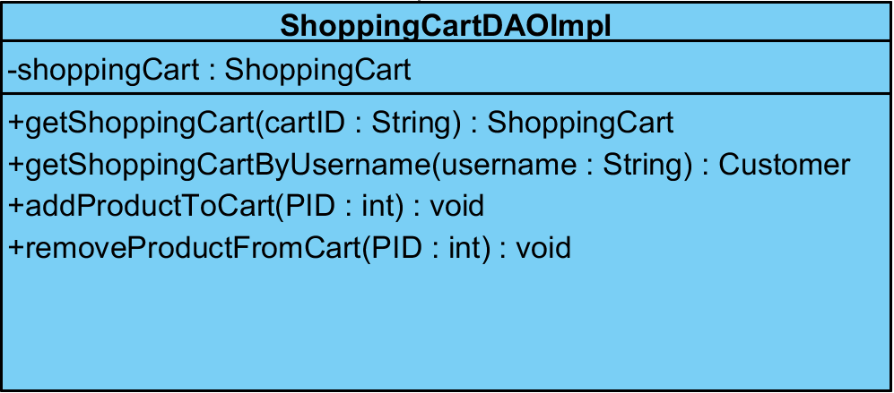

**Method:**

|  |  |  |  |
| --- | --- | --- | --- |
| **ID** | **Name** | **Description** | **Remark** |
| 1 | getShoppingCart() | This method uses for getting the shopping cart from database. | **Return Type**: ShoppingCart  **Parameters:** cartID |
| 2 | getShoppingCartByUsername() | This method uses for getting the shopping cart by using customer’s username from database. | **Return Type**: Customer  **Parameters:** username |
| 3 | addProductToCart() | This method uses for adding the product and quantity into shopping cart. | **Return Type**: void  **Parameters:** PID |
| 4 | removeProductFromCart() | This method uses for removing the product and quantity from shopping cart. | **Return Type**: void  **Parameters:** PID |

**Class Name**: ShoppingCartDAO

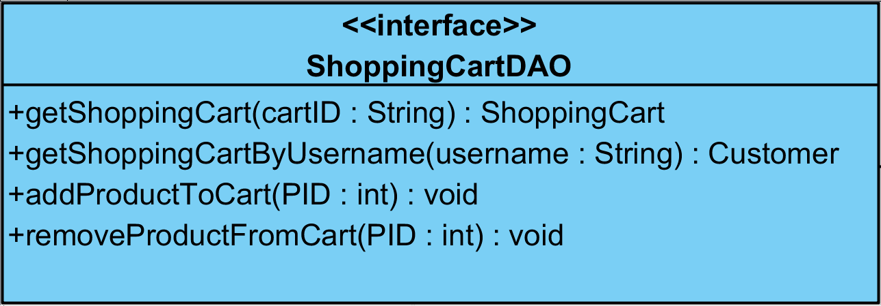

**Method:**

|  |  |  |  |
| --- | --- | --- | --- |
| **ID** | **Name** | **Description** | **Remark** |
| 1 | getShoppingCart() | This method uses for getting the shopping cart from database. | **Return Type**: ShoppingCart  **Parameters:** cartID |
| 2 | getShoppingCartByUsername() | This method uses for getting the shopping cart by using customer’s username from database. | **Return Type**: Customer  **Parameters:** username |
| 3 | addProductToCart() | This method uses for adding the product and quantity into shopping cart. | **Return Type**: void  **Parameters:** PID |
| 4 | removeProductFromCart() | This method uses for removing the product and quantity from shopping cart. | **Return Type**: void  **Parameters:** PID |

**Class Name**: HistoryController

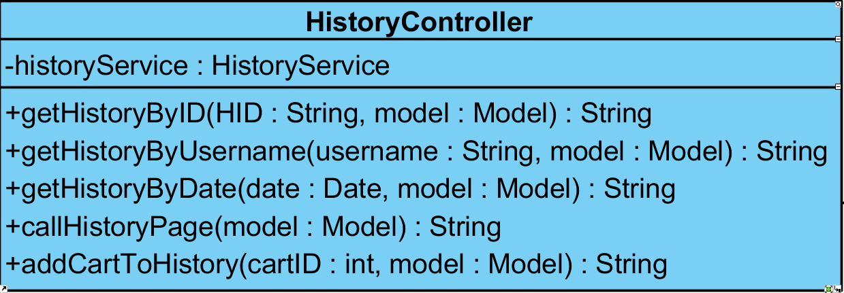

**Method:**

|  |  |  |  |
| --- | --- | --- | --- |
| **ID** | **Name** | **Description** | **Remark** |
| 1 | getHistoryByID() | This method uses for getting the history by using customer’s id from database. | **Return Type**: String  **Parameters:** HID, model |
| 2 | getHistoryByUsername() | This method uses for getting the history by using customer’s username from database. | **Return Type**: String  **Parameters:** username, model |
| 3 | getHistoryByDate() | This method uses for getting the history by using transaction’s date from database. | **Return Type**: String  **Parameters:** date, model |
| 4 | callHistoryPage() | This method uses for calling the history page from database. | **Return Type**: String  **Parameters:** model |
| 5 | addCartToHistory() | This method uses for adding the shopping cart into the history database. | **Return Type**: String  **Parameters:** cartID, model |

**Class Name**: HistoryService

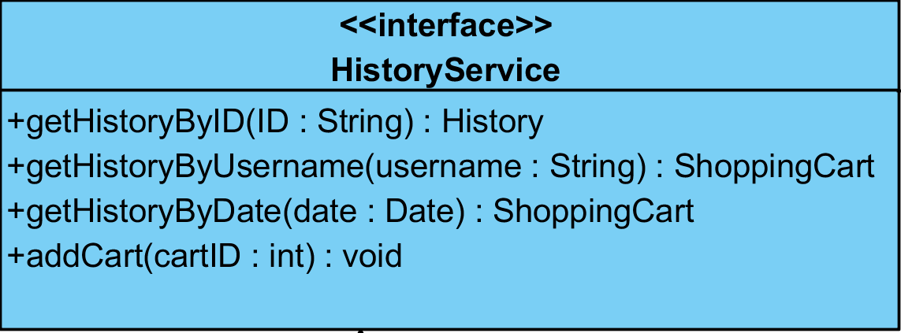

**Method:**

|  |  |  |  |
| --- | --- | --- | --- |
| **ID** | **Name** | **Description** | **Remark** |
| 1 | getHistoryByID() | This method uses for getting the history by using customer’s id from database. | **Return Type**: History  **Parameters:** ID |
| 2 | getHistoryByUsername() | This method uses for getting the history by using customer’s username from database. | **Return Type**: ShoppingCart  **Parameters:** username |
| 3 | getHistoryByDate() | This method uses for getting the history by using transaction’s date from database. | **Return Type**: ShoppingCart  **Parameters:** date |
| 4 | addCart() | This method uses for adding the shopping cart into database. | **Return Type**: void  **Parameters:** cartID |

**Class Name**: HistoryServiceImpl

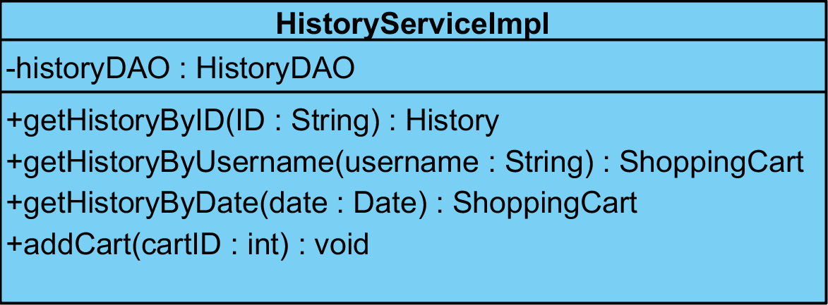

**Method:**

|  |  |  |  |
| --- | --- | --- | --- |
| **ID** | **Name** | **Description** | **Remark** |
| 1 | getHistoryByID() | This method uses for getting the history by using customer’s id from database. | **Return Type**: History  **Parameters:** ID |
| 2 | getHistoryByUsername() | This method uses for getting the history by using customer’s username from database. | **Return Type**: ShoppingCart  **Parameters:** username |
| 3 | getHistoryByDate() | This method uses for getting the history by using transaction’s date from database. | **Return Type**: ShoppingCart  **Parameters:** date |
| 4 | addCart() | This method uses for adding the shopping cart into database. | **Return Type**: void  **Parameters:** cartID |

**Class Name**: HistoryDAO

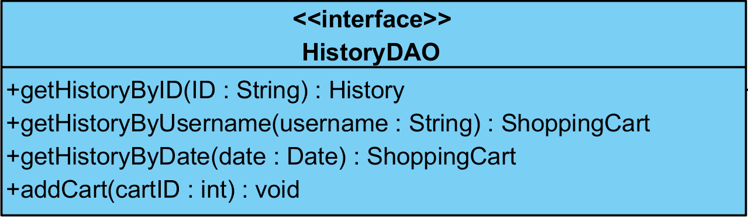

**Method:**

|  |  |  |  |
| --- | --- | --- | --- |
| **ID** | **Name** | **Description** | **Remark** |
| 1 | getHistoryByID() | This method uses for getting the history by using customer’s id from database. | **Return Type**: History  **Parameters:** ID |
| 2 | getHistoryByUsername() | This method uses for getting the history by using customer’s username from database. | **Return Type**: ShoppingCart  **Parameters:** username |
| 3 | getHistoryByDate() | This method uses for getting the history by using transaction’s date from database. | **Return Type**: ShoppingCart  **Parameters:** date |
| 4 | addCart() | This method uses for adding the shopping cart into database. | **Return Type**: void  **Parameters:** cartID |

**Class Name**: HistoryDAOImpl

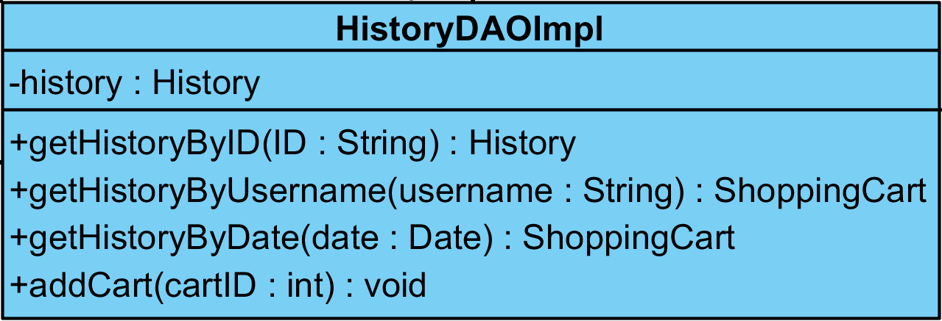

**Method:**

|  |  |  |  |
| --- | --- | --- | --- |
| **ID** | **Name** | **Description** | **Remark** |
| 1 | getHistoryByID() | This method uses for getting the history by using customer’s id from database. | **Return Type**: History  **Parameters:** ID |
| 2 | getHistoryByUsername() | This method uses for getting the history by using customer’s username from database. | **Return Type**: ShoppingCart  **Parameters:** username |
| 3 | getHistoryByDate() | This method uses for getting the history by using transaction’s date from database. | **Return Type**: ShoppingCart  **Parameters:** date |
| 4 | addCart() | This method uses for adding the shopping cart into database. | **Return Type**: void  **Parameters:** cartID |

**Class Name**: Customer

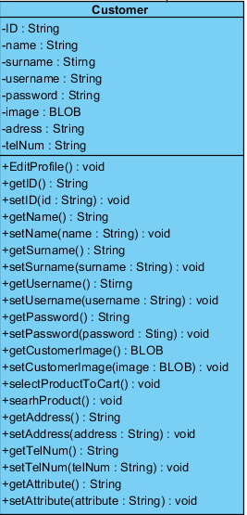

**Method:**

|  |  |  |  |
| --- | --- | --- | --- |
| **ID** | **Name** | **Description** | **Remark** |
| 1 | EditProfile() | This method uses for editing the user’s profile. | **Return Type**: void  **Parameters:** None |

**Class Name**: CustomerController

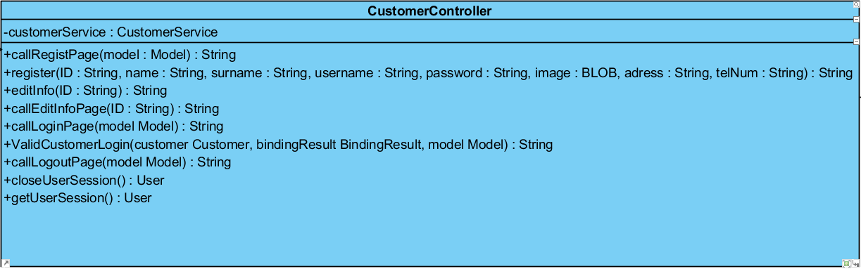

**Method:**

|  |  |  |  |
| --- | --- | --- | --- |
| **ID** | **Name** | **Description** | **Remark** |
| 1 | callRegistPage() | This method uses for calling the registration page from database. | **Return Type**: String  **Parameters:** model |
| 2 | register() | This method uses for registering the new customer into database. | **Return Type**: String  **Parameters:** ID, name, surname, username, password, image, address, telNum |
| 3 | editInfo () | This method uses for editing the customer’s information from database. | **Return Type**: String  **Parameters:** ID |
| 4 | callEditInfoPage () | This method uses for calling the edit information page from database. | **Return Type**: String  **Parameters:** ID |
| 5 | callLoginPage() | This method uses for calling the login page from database. | **Return Type**: String  **Parameters:** model |
| 6 | ValidCustomerLogin() | This method uses for verifying the customer profile through the login. | **Return Type**: String  **Parameters:** customer, bindingResult, model |
| 7 | callLogoutPage() | This method uses for calling the logout page from database. | **Return Type**: String  **Parameters:** model |
| 8 | closeUserSession() | This method uses for finding the close user’s session from database. | **Return Type**: User  **Parameters:** None |
| 9 | getUserSession() | This method uses for getting the user’s session from database. | **Return Type**: User  **Parameters:** None |

**Class Name**: CustomerService

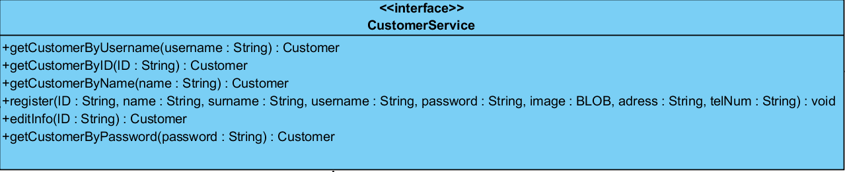

**Method:**

|  |  |  |  |
| --- | --- | --- | --- |
| **ID** | **Name** | **Description** | **Remark** |
| 1 | getCustomerByID() | This method uses for getting the details of customer by using customer’s id from database. | **Return Type**: Customer  **Parameters:** ID |
| 2 | getCustomerByUsername() | This method uses for getting the details of customer by using customer’s username from database. | **Return Type**: Customer  **Parameters:** username |
| 3 | getCustomerByName() | This method uses for getting the details of customer by using customer’s name from database. | **Return Type**: Customer  **Parameters:** name |
| 4 | getCustomerByPassword() | This method uses for getting the details of customer by using customer’s password from database. | **Return Type**: Customer  **Parameters:** password |
| 5 | register() | This method uses for registering the new customer into database. | **Return Type**: void  **Parameters:** ID, name, surname, username, password, image, address, telNum |
| 6 | editInfo () | This method uses for editing the customer’s information from database. | **Return Type**: Customer  **Parameters:** ID |

**Class Name**: CustomerServiceImpl

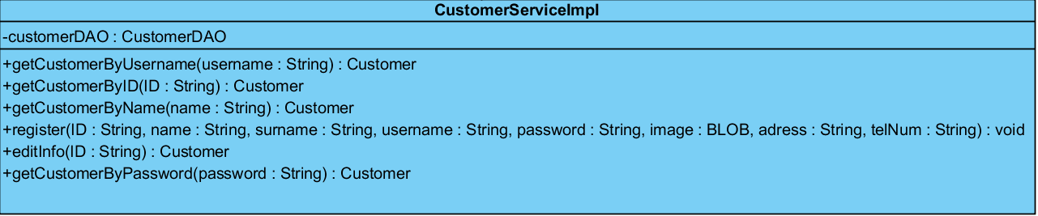

**Method:**

|  |  |  |  |
| --- | --- | --- | --- |
| **ID** | **Name** | **Description** | **Remark** |
| 1 | getCustomerByID() | This method uses for getting the details of customer by using customer’s id from database. | **Return Type**: Customer  **Parameters:** ID |
| 2 | getCustomerByUsername() | This method uses for getting the details of customer by using customer’s username from database. | **Return Type**: Customer  **Parameters:** username |
| 3 | getCustomerByName() | This method uses for getting the details of customer by using customer’s name from database. | **Return Type**: Customer  **Parameters:** name |
| 4 | getCustomerByPassword() | This method uses for getting the details of customer by using customer’s password from database. | **Return Type**: Customer  **Parameters:** password |
| 5 | register() | This method uses for registering the new customer into database. | **Return Type**: void  **Parameters:** ID, name, surname, username, password, image, address, telNum |
| 6 | editInfo () | This method uses for editing the customer’s information from database. | **Return Type**: Customer  **Parameters:** ID |

**Class Name**: CustomerDAO

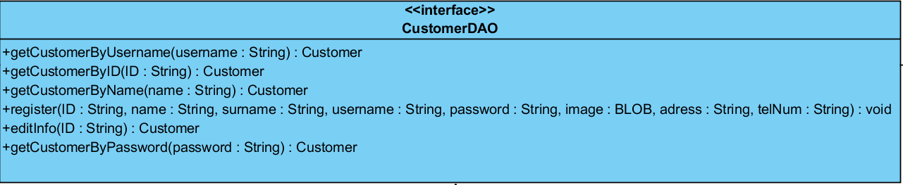

**Method:**

|  |  |  |  |
| --- | --- | --- | --- |
| **ID** | **Name** | **Description** | **Remark** |
| 1 | getCustomerByID() | This method uses for getting the details of customer by using customer’s id from database. | **Return Type**: Customer  **Parameters:** ID |
| 2 | getCustomerByUsername() | This method uses for getting the details of customer by using customer’s username from database. | **Return Type**: Customer  **Parameters:** username |
| 3 | getCustomerByName() | This method uses for getting the details of customer by using customer’s name from database. | **Return Type**: Customer  **Parameters:** name |
| 4 | getCustomerByPassword() | This method uses for getting the details of customer by using customer’s password from database. | **Return Type**: Customer  **Parameters:** password |
| 5 | register() | This method uses for registering the new customer into database. | **Return Type**: void  **Parameters:** ID, name, surname, username, password, image, address, telNum |
| 6 | editInfo () | This method uses for editing the customer’s information from database. | **Return Type**: Customer  **Parameters:** ID |

**Class Name**: CustomerDAOImpl

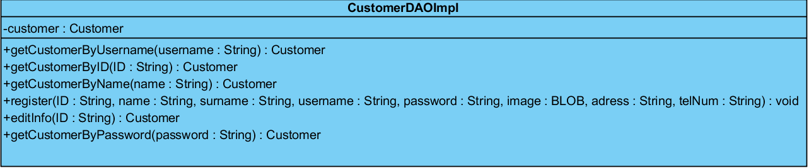

**Method:**

|  |  |  |  |
| --- | --- | --- | --- |
| **ID** | **Name** | **Description** | **Remark** |
| 1 | getCustomerByID() | This method uses for getting the details of customer by using customer’s id from database. | **Return Type**: Customer  **Parameters:** ID |
| 2 | getCustomerByUsername() | This method uses for getting the details of customer by using customer’s username from database. | **Return Type**: Customer  **Parameters:** username |
| 3 | getCustomerByName() | This method uses for getting the details of customer by using customer’s name from database. | **Return Type**: Customer  **Parameters:** name |
| 4 | getCustomerByPassword() | This method uses for getting the details of customer by using customer’s password from database. | **Return Type**: Customer  **Parameters:** password |
| 5 | register() | This method uses for registering the new customer into database. | **Return Type**: void  **Parameters:** ID, name, surname, username, password, image, address, telNum |
| 6 | editInfo () | This method uses for editing the customer’s information from database. | **Return Type**: Customer  **Parameters:** ID |

**Class Name**: Admin

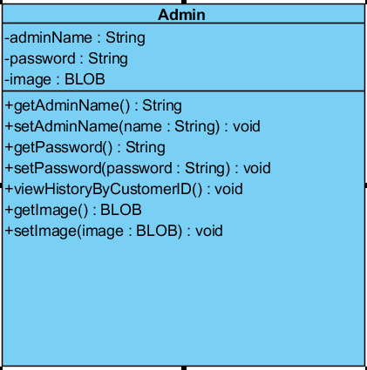

**Method:**

|  |  |  |  |
| --- | --- | --- | --- |
| **ID** | **Name** | **Description** | **Remark** |
| 1 | ViewHistoryByCustomerID() | This method uses for viewing the customer’s history by using customer’s id from database. | **Return Type**: void  **Parameters:** None |

**Class Name**: AdminController

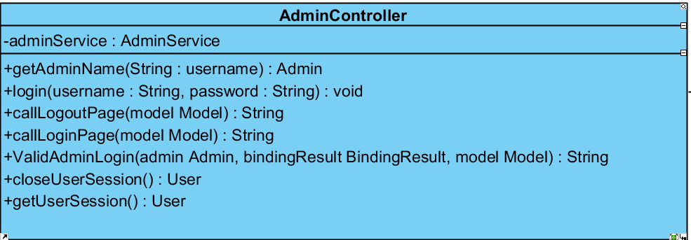

**Method:**

|  |  |  |  |
| --- | --- | --- | --- |
| **ID** | **Name** | **Description** | **Remark** |
| 1 | getAdminName() | This method uses for getting the name of admin from database. | **Return Type**: Admin  **Parameters:** username |
| 2 | login() | This method uses for logging in to the system. | **Return Type**: void  **Parameters:** username**,** password |
| 3 | callLoginPage() | This method uses for calling the login page from database. | **Return Type**: String  **Parameters:** model |
| 4 | callLogoutPage() | This method uses for calling the logout page from database. | **Return Type**: String  **Parameters:** model |
| 5 | ValidAdminLogin() | This method uses for verifying the admin profile through the login. | **Return Type**: String  **Parameters:** customer, bindingResult, model |
| 6 | closeUserSession() | This method uses for finding the close user’s session from database. | **Return Type**: User  **Parameters:** None |
| 7 | getUserSession() | This method uses for getting the user’s session from database. | **Return Type**: User  **Parameters:** None |

**Class Name**: AdminService

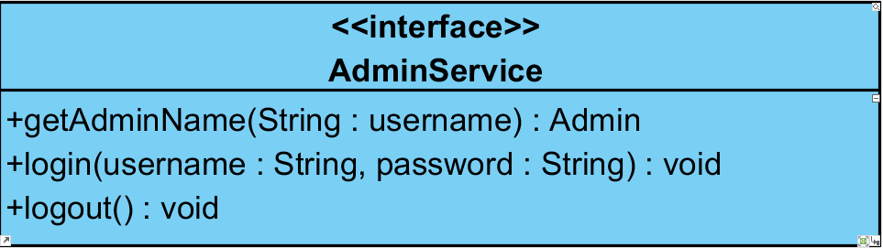

**Method:**

|  |  |  |  |
| --- | --- | --- | --- |
| **ID** | **Name** | **Description** | **Remark** |
| 1 | getAdminName() | This method uses for getting the name of admin from database. | **Return Type**: Admin  **Parameters:** username |
| 2 | login() | This method uses for logging in to the system. | **Return Type**: void  **Parameters:** username**,** password |
| 3 | logout() | This method uses for logging out from the system. | **Return Type**: void  **Parameters:** None |

**Class Name**: AdminServiceImpl

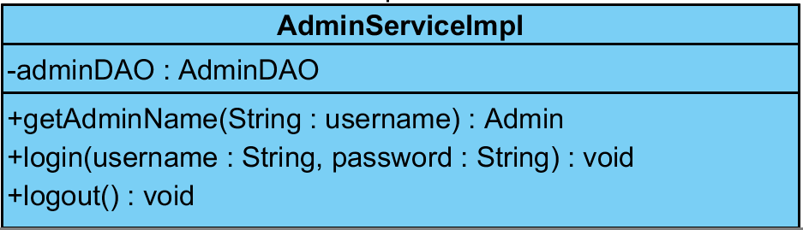

**Method:**

|  |  |  |  |
| --- | --- | --- | --- |
| **ID** | **Name** | **Description** | **Remark** |
| 1 | getAdminName() | This method uses for getting the name of admin from database. | **Return Type**: Admin  **Parameters:** username |
| 2 | login() | This method uses for logging in to the system. | **Return Type**: void  **Parameters:** username**,** password |
| 3 | logout() | This method uses for logging out from the system. | **Return Type**: void  **Parameters:** None |

**Class Name**: AdminDAO

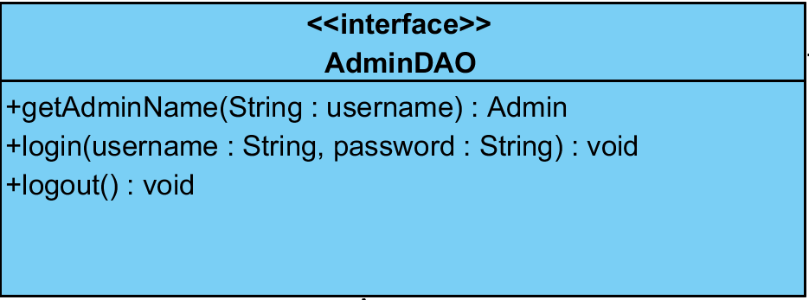

**Method:**

|  |  |  |  |
| --- | --- | --- | --- |
| **ID** | **Name** | **Description** | **Remark** |
| 1 | getAdminName() | This method uses for getting the name of admin from database. | **Return Type**: Admin  **Parameters:** username |
| 2 | login() | This method uses for logging in to the system. | **Return Type**: void  **Parameters:** username**,** password |
| 3 | logout() | This method uses for logging out from the system. | **Return Type**: void  **Parameters:** None |

**Class Name**: AdminDAOImpl

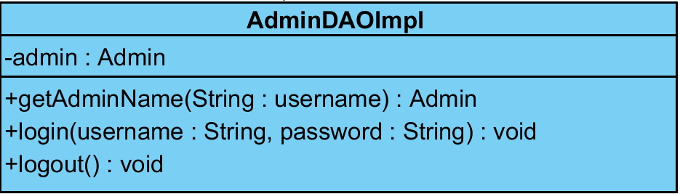

**Method:**

|  |  |  |  |
| --- | --- | --- | --- |
| **ID** | **Name** | **Description** | **Remark** |
| 1 | getAdminName() | This method uses for getting the name of admin from database. | **Return Type**: Admin  **Parameters:** username |
| 2 | login() | This method uses for logging in to the system. | **Return Type**: void  **Parameters:** username**,** password |
| 3 | logout() | This method uses for logging out from the system. | **Return Type**: void  **Parameters:** None |

**Traceability Record**

**1. URS : Class diagram**

|  |  |  |  |  |  |  |  |  |  |  |  |  |  |  |  |  |  |  |  |  |  |  |  |  |  |  |  |  |  |  |  |
| --- | --- | --- | --- | --- | --- | --- | --- | --- | --- | --- | --- | --- | --- | --- | --- | --- | --- | --- | --- | --- | --- | --- | --- | --- | --- | --- | --- | --- | --- | --- | --- |
| URS    CD | CD-01 | CD-02 | CD-03 | CD-04 | CD-05 | CD-06 | CD-07 | CD-08 | CD-09 | CD-10 | CD-11 | CD-12 | CD-13 | CD-14 | CD-15 | CD-16 | CD-17 | CD-18 | CD-19 | CD-20 | CD-21 | CD-22 | CD-23 | CD-24 | CD-25 | CD-26 | CD-27 | CD-28 | CD-29 | CD-30 | CD-31 |
| URS-01 | http://www.decodeunicode.org/en/data/glyph/196x196/2714.gif |  |  |  |  | http://www.decodeunicode.org/en/data/glyph/196x196/2714.gif | http://www.decodeunicode.org/en/data/glyph/196x196/2714.gif | http://www.decodeunicode.org/en/data/glyph/196x196/2714.gif | http://www.decodeunicode.org/en/data/glyph/196x196/2714.gif | http://www.decodeunicode.org/en/data/glyph/196x196/2714.gif |  |  |  |  |  |  |  |  |  |  |  |  |  |  |  |  |  |  |  |  | http://www.decodeunicode.org/en/data/glyph/196x196/2714.gif |
| URS-02 |  |  |  |  | http://www.decodeunicode.org/en/data/glyph/196x196/2714.gif |  |  |  |  |  |  |  |  |  |  |  |  |  |  |  |  |  |  |  |  | http://www.decodeunicode.org/en/data/glyph/196x196/2714.gif | http://www.decodeunicode.org/en/data/glyph/196x196/2714.gif | http://www.decodeunicode.org/en/data/glyph/196x196/2714.gif | http://www.decodeunicode.org/en/data/glyph/196x196/2714.gif | http://www.decodeunicode.org/en/data/glyph/196x196/2714.gif | http://www.decodeunicode.org/en/data/glyph/196x196/2714.gif |
| URS-03 | http://www.decodeunicode.org/en/data/glyph/196x196/2714.gif |  |  |  |  | http://www.decodeunicode.org/en/data/glyph/196x196/2714.gif | http://www.decodeunicode.org/en/data/glyph/196x196/2714.gif | http://www.decodeunicode.org/en/data/glyph/196x196/2714.gif | http://www.decodeunicode.org/en/data/glyph/196x196/2714.gif | http://www.decodeunicode.org/en/data/glyph/196x196/2714.gif |  |  |  |  |  |  |  |  |  |  |  |  |  |  |  |  |  |  |  |  | http://www.decodeunicode.org/en/data/glyph/196x196/2714.gif |
| URS-04 | http://www.decodeunicode.org/en/data/glyph/196x196/2714.gif |  |  |  |  | http://www.decodeunicode.org/en/data/glyph/196x196/2714.gif | http://www.decodeunicode.org/en/data/glyph/196x196/2714.gif | http://www.decodeunicode.org/en/data/glyph/196x196/2714.gif | http://www.decodeunicode.org/en/data/glyph/196x196/2714.gif | http://www.decodeunicode.org/en/data/glyph/196x196/2714.gif |  |  |  |  |  |  |  |  |  |  |  |  |  |  |  |  |  |  |  |  | http://www.decodeunicode.org/en/data/glyph/196x196/2714.gif |
| URS-05 |  |  |  | http://www.decodeunicode.org/en/data/glyph/196x196/2714.gif | http://www.decodeunicode.org/en/data/glyph/196x196/2714.gif |  |  |  |  |  |  |  |  |  |  |  |  |  |  |  | http://www.decodeunicode.org/en/data/glyph/196x196/2714.gif | http://www.decodeunicode.org/en/data/glyph/196x196/2714.gif | http://www.decodeunicode.org/en/data/glyph/196x196/2714.gif | http://www.decodeunicode.org/en/data/glyph/196x196/2714.gif | http://www.decodeunicode.org/en/data/glyph/196x196/2714.gif |  |  |  |  |  | http://www.decodeunicode.org/en/data/glyph/196x196/2714.gif |
| URS-06 |  | http://www.decodeunicode.org/en/data/glyph/196x196/2714.gif |  |  | http://www.decodeunicode.org/en/data/glyph/196x196/2714.gif |  |  |  |  |  | http://www.decodeunicode.org/en/data/glyph/196x196/2714.gif | http://www.decodeunicode.org/en/data/glyph/196x196/2714.gif | http://www.decodeunicode.org/en/data/glyph/196x196/2714.gif | http://www.decodeunicode.org/en/data/glyph/196x196/2714.gif | http://www.decodeunicode.org/en/data/glyph/196x196/2714.gif |  |  |  |  |  |  |  |  |  |  |  |  |  |  |  | http://www.decodeunicode.org/en/data/glyph/196x196/2714.gif |
| URS-07 | http://www.decodeunicode.org/en/data/glyph/196x196/2714.gif |  |  | http://www.decodeunicode.org/en/data/glyph/196x196/2714.gif |  |  |  |  |  |  |  |  |  |  |  |  |  |  |  |  | http://www.decodeunicode.org/en/data/glyph/196x196/2714.gif | http://www.decodeunicode.org/en/data/glyph/196x196/2714.gif | http://www.decodeunicode.org/en/data/glyph/196x196/2714.gif | http://www.decodeunicode.org/en/data/glyph/196x196/2714.gif | http://www.decodeunicode.org/en/data/glyph/196x196/2714.gif |  |  |  |  |  | http://www.decodeunicode.org/en/data/glyph/196x196/2714.gif |
| URS-08 | http://www.decodeunicode.org/en/data/glyph/196x196/2714.gif |  |  | http://www.decodeunicode.org/en/data/glyph/196x196/2714.gif |  |  |  |  |  |  |  |  |  |  |  |  |  |  |  |  | http://www.decodeunicode.org/en/data/glyph/196x196/2714.gif | http://www.decodeunicode.org/en/data/glyph/196x196/2714.gif | http://www.decodeunicode.org/en/data/glyph/196x196/2714.gif | http://www.decodeunicode.org/en/data/glyph/196x196/2714.gif | http://www.decodeunicode.org/en/data/glyph/196x196/2714.gif |  |  |  |  |  | http://www.decodeunicode.org/en/data/glyph/196x196/2714.gif |
| URS-09 | http://www.decodeunicode.org/en/data/glyph/196x196/2714.gif |  |  | http://www.decodeunicode.org/en/data/glyph/196x196/2714.gif |  | http://www.decodeunicode.org/en/data/glyph/196x196/2714.gif |  |  |  |  |  |  |  |  |  | http://www.decodeunicode.org/en/data/glyph/196x196/2714.gif | http://www.decodeunicode.org/en/data/glyph/196x196/2714.gif | http://www.decodeunicode.org/en/data/glyph/196x196/2714.gif | http://www.decodeunicode.org/en/data/glyph/196x196/2714.gif | http://www.decodeunicode.org/en/data/glyph/196x196/2714.gif | http://www.decodeunicode.org/en/data/glyph/196x196/2714.gif | http://www.decodeunicode.org/en/data/glyph/196x196/2714.gif | http://www.decodeunicode.org/en/data/glyph/196x196/2714.gif | http://www.decodeunicode.org/en/data/glyph/196x196/2714.gif | http://www.decodeunicode.org/en/data/glyph/196x196/2714.gif |  |  |  |  |  | http://www.decodeunicode.org/en/data/glyph/196x196/2714.gif |
| URS-10 | http://www.decodeunicode.org/en/data/glyph/196x196/2714.gif |  | http://www.decodeunicode.org/en/data/glyph/196x196/2714.gif | http://www.decodeunicode.org/en/data/glyph/196x196/2714.gif |  |  |  |  |  |  |  |  |  |  |  | http://www.decodeunicode.org/en/data/glyph/196x196/2714.gif | http://www.decodeunicode.org/en/data/glyph/196x196/2714.gif | http://www.decodeunicode.org/en/data/glyph/196x196/2714.gif | http://www.decodeunicode.org/en/data/glyph/196x196/2714.gif | http://www.decodeunicode.org/en/data/glyph/196x196/2714.gif |  |  |  |  |  |  |  |  |  |  | http://www.decodeunicode.org/en/data/glyph/196x196/2714.gif |
| URS-11 | http://www.decodeunicode.org/en/data/glyph/196x196/2714.gif |  | http://www.decodeunicode.org/en/data/glyph/196x196/2714.gif |  |  |  |  |  |  |  |  |  |  |  |  | http://www.decodeunicode.org/en/data/glyph/196x196/2714.gif | http://www.decodeunicode.org/en/data/glyph/196x196/2714.gif | http://www.decodeunicode.org/en/data/glyph/196x196/2714.gif | http://www.decodeunicode.org/en/data/glyph/196x196/2714.gif | http://www.decodeunicode.org/en/data/glyph/196x196/2714.gif |  |  |  |  |  |  |  |  |  |  | http://www.decodeunicode.org/en/data/glyph/196x196/2714.gif |
| URS-12 | http://www.decodeunicode.org/en/data/glyph/196x196/2714.gif | http://www.decodeunicode.org/en/data/glyph/196x196/2714.gif | http://www.decodeunicode.org/en/data/glyph/196x196/2714.gif |  |  |  |  |  |  |  | http://www.decodeunicode.org/en/data/glyph/196x196/2714.gif | http://www.decodeunicode.org/en/data/glyph/196x196/2714.gif | http://www.decodeunicode.org/en/data/glyph/196x196/2714.gif | http://www.decodeunicode.org/en/data/glyph/196x196/2714.gif | http://www.decodeunicode.org/en/data/glyph/196x196/2714.gif | http://www.decodeunicode.org/en/data/glyph/196x196/2714.gif | http://www.decodeunicode.org/en/data/glyph/196x196/2714.gif | http://www.decodeunicode.org/en/data/glyph/196x196/2714.gif | http://www.decodeunicode.org/en/data/glyph/196x196/2714.gif | http://www.decodeunicode.org/en/data/glyph/196x196/2714.gif |  |  |  |  |  |  |  |  |  |  | http://www.decodeunicode.org/en/data/glyph/196x196/2714.gif |
| URS-13 | http://www.decodeunicode.org/en/data/glyph/196x196/2714.gif | http://www.decodeunicode.org/en/data/glyph/196x196/2714.gif | http://www.decodeunicode.org/en/data/glyph/196x196/2714.gif |  |  |  |  |  |  |  | http://www.decodeunicode.org/en/data/glyph/196x196/2714.gif | http://www.decodeunicode.org/en/data/glyph/196x196/2714.gif | http://www.decodeunicode.org/en/data/glyph/196x196/2714.gif | http://www.decodeunicode.org/en/data/glyph/196x196/2714.gif | http://www.decodeunicode.org/en/data/glyph/196x196/2714.gif | http://www.decodeunicode.org/en/data/glyph/196x196/2714.gif | http://www.decodeunicode.org/en/data/glyph/196x196/2714.gif | http://www.decodeunicode.org/en/data/glyph/196x196/2714.gif | http://www.decodeunicode.org/en/data/glyph/196x196/2714.gif | http://www.decodeunicode.org/en/data/glyph/196x196/2714.gif |  |  |  |  |  |  |  |  |  |  | http://www.decodeunicode.org/en/data/glyph/196x196/2714.gif |

**2. SRS : URS**

|  |  |  |  |  |  |  |  |  |  |  |  |  |  |
| --- | --- | --- | --- | --- | --- | --- | --- | --- | --- | --- | --- | --- | --- |
| SRS    URS | URS-01 | URS-02 | URS-03 | URS-04 | URS-05 | URS-06 | URS-07 | URS-08 | URS-09 | URS-10 | URS-11 | URS-12 | URS-13 |
| SRS-01 | http://www.decodeunicode.org/en/data/glyph/196x196/2714.gif |  |  |  |  |  |  |  |  |  |  |  |  |
| SRS-02 | http://www.decodeunicode.org/en/data/glyph/196x196/2714.gif |  |  |  |  |  |  |  |  |  |  |  |  |
| SRS-03 | http://www.decodeunicode.org/en/data/glyph/196x196/2714.gif | http://www.decodeunicode.org/en/data/glyph/196x196/2714.gif |  |  |  |  |  |  |  |  |  |  |  |
| SRS-04 | http://www.decodeunicode.org/en/data/glyph/196x196/2714.gif | http://www.decodeunicode.org/en/data/glyph/196x196/2714.gif | http://www.decodeunicode.org/en/data/glyph/196x196/2714.gif | http://www.decodeunicode.org/en/data/glyph/196x196/2714.gif |  |  |  |  |  |  |  |  |  |
| SRS-05 |  | http://www.decodeunicode.org/en/data/glyph/196x196/2714.gif |  |  |  |  |  |  |  |  |  |  |  |
| SRS-06 |  | http://www.decodeunicode.org/en/data/glyph/196x196/2714.gif |  |  |  |  |  |  |  |  |  |  |  |
| SRS-07 |  |  | http://www.decodeunicode.org/en/data/glyph/196x196/2714.gif |  |  |  |  |  |  |  |  |  |  |
| SRS-08 |  |  | http://www.decodeunicode.org/en/data/glyph/196x196/2714.gif |  |  |  |  |  |  |  |  |  |  |
| SRS-09 |  |  | http://www.decodeunicode.org/en/data/glyph/196x196/2714.gif |  |  |  |  |  |  |  |  |  |  |
| SRS-10 |  |  | http://www.decodeunicode.org/en/data/glyph/196x196/2714.gif | http://www.decodeunicode.org/en/data/glyph/196x196/2714.gif |  |  |  |  |  |  |  |  |  |
| SRS-11 |  |  | http://www.decodeunicode.org/en/data/glyph/196x196/2714.gif | http://www.decodeunicode.org/en/data/glyph/196x196/2714.gif |  |  |  |  |  |  |  |  |  |
| SRS-12 |  |  | http://www.decodeunicode.org/en/data/glyph/196x196/2714.gif | http://www.decodeunicode.org/en/data/glyph/196x196/2714.gif |  |  |  |  |  |  |  |  |  |
| SRS-13 |  |  | http://www.decodeunicode.org/en/data/glyph/196x196/2714.gif | http://www.decodeunicode.org/en/data/glyph/196x196/2714.gif |  |  |  |  |  |  |  |  |  |
| SRS-14 |  |  | http://www.decodeunicode.org/en/data/glyph/196x196/2714.gif | http://www.decodeunicode.org/en/data/glyph/196x196/2714.gif |  |  |  |  |  |  |  |  |  |
| SRS-15 |  |  | http://www.decodeunicode.org/en/data/glyph/196x196/2714.gif | http://www.decodeunicode.org/en/data/glyph/196x196/2714.gif |  | http://www.decodeunicode.org/en/data/glyph/196x196/2714.gif |  |  |  |  |  |  |  |
| SRS-16 |  |  | http://www.decodeunicode.org/en/data/glyph/196x196/2714.gif | http://www.decodeunicode.org/en/data/glyph/196x196/2714.gif |  |  |  |  |  |  |  |  |  |
| SRS-17 |  |  | http://www.decodeunicode.org/en/data/glyph/196x196/2714.gif | http://www.decodeunicode.org/en/data/glyph/196x196/2714.gif |  |  |  |  |  |  |  |  |  |
| SRS-18 |  |  | http://www.decodeunicode.org/en/data/glyph/196x196/2714.gif | http://www.decodeunicode.org/en/data/glyph/196x196/2714.gif |  | http://www.decodeunicode.org/en/data/glyph/196x196/2714.gif |  |  |  |  |  |  |  |
| SRS-19 |  |  |  | http://www.decodeunicode.org/en/data/glyph/196x196/2714.gif |  |  |  |  |  |  |  |  |  |
| SRS-20 |  |  |  |  | http://www.decodeunicode.org/en/data/glyph/196x196/2714.gif |  |  |  |  |  |  |  |  |
| SRS-21 |  |  |  |  | http://www.decodeunicode.org/en/data/glyph/196x196/2714.gif |  |  |  |  |  |  |  |  |
| SRS-22 |  |  |  |  |  | http://www.decodeunicode.org/en/data/glyph/196x196/2714.gif |  |  |  |  |  |  |  |
| SRS-23 |  |  |  |  |  | http://www.decodeunicode.org/en/data/glyph/196x196/2714.gif |  |  |  |  |  |  |  |
| SRS-24 |  |  |  |  |  |  | http://www.decodeunicode.org/en/data/glyph/196x196/2714.gif |  |  |  |  |  |  |
| SRS-25 |  |  |  |  |  |  | http://www.decodeunicode.org/en/data/glyph/196x196/2714.gif |  |  |  |  |  |  |
| SRS-26 |  |  |  |  |  |  |  | http://www.decodeunicode.org/en/data/glyph/196x196/2714.gif |  |  |  |  |  |
| SRS-27 |  |  |  |  |  |  |  | http://www.decodeunicode.org/en/data/glyph/196x196/2714.gif |  |  |  |  |  |
| SRS-28 |  |  |  |  |  |  |  |  | http://www.decodeunicode.org/en/data/glyph/196x196/2714.gif |  |  |  |  |
| SRS-29 |  |  |  |  |  |  |  |  | http://www.decodeunicode.org/en/data/glyph/196x196/2714.gif |  |  |  |  |
| SRS-30 |  |  |  |  |  |  |  |  | http://www.decodeunicode.org/en/data/glyph/196x196/2714.gif |  |  |  |  |
| SRS-31 |  |  |  |  |  |  |  |  | http://www.decodeunicode.org/en/data/glyph/196x196/2714.gif |  |  |  |  |
| SRS-32 |  |  |  |  |  |  |  |  |  | http://www.decodeunicode.org/en/data/glyph/196x196/2714.gif |  |  |  |
| SRS-33 |  |  |  |  |  |  |  |  |  | http://www.decodeunicode.org/en/data/glyph/196x196/2714.gif |  |  |  |
| SRS-34 |  |  |  |  |  |  |  |  |  | http://www.decodeunicode.org/en/data/glyph/196x196/2714.gif |  |  |  |
| SRS-35 |  |  |  |  |  |  |  |  |  |  | http://www.decodeunicode.org/en/data/glyph/196x196/2714.gif |  |  |
| SRS-36 |  |  |  |  |  |  |  |  |  |  | http://www.decodeunicode.org/en/data/glyph/196x196/2714.gif |  |  |
| SRS-37 |  |  |  |  |  |  |  |  |  |  | http://www.decodeunicode.org/en/data/glyph/196x196/2714.gif |  |  |
| SRS-38 |  |  |  |  |  |  |  |  |  |  | http://www.decodeunicode.org/en/data/glyph/196x196/2714.gif |  |  |
| SRS-39 |  |  |  |  |  |  |  |  |  |  |  | http://www.decodeunicode.org/en/data/glyph/196x196/2714.gif |  |
| SRS-40 |  |  |  |  |  |  |  |  |  |  |  | http://www.decodeunicode.org/en/data/glyph/196x196/2714.gif |  |
| SRS-41 |  |  |  |  |  |  |  |  |  |  |  | http://www.decodeunicode.org/en/data/glyph/196x196/2714.gif |  |
| SRS-42 |  |  |  |  |  |  |  |  |  |  |  | http://www.decodeunicode.org/en/data/glyph/196x196/2714.gif |  |
| SRS-43 |  |  |  |  |  |  |  |  |  |  |  | http://www.decodeunicode.org/en/data/glyph/196x196/2714.gif |  |
| SRS-44 |  |  |  |  |  |  |  |  |  |  |  | http://www.decodeunicode.org/en/data/glyph/196x196/2714.gif |  |
| SRS-45 |  |  |  |  |  |  |  |  |  |  |  |  | http://www.decodeunicode.org/en/data/glyph/196x196/2714.gif |
| SRS-46 |  |  |  |  |  |  |  |  |  |  |  |  | http://www.decodeunicode.org/en/data/glyph/196x196/2714.gif |

**3. URS : Use case diagram**

|  |  |  |  |  |  |  |  |  |  |  |  |  |  |
| --- | --- | --- | --- | --- | --- | --- | --- | --- | --- | --- | --- | --- | --- |
| URS    Use case | UC-01 | UC-02 | UC-03 | UC-04 | UC-05 | UC-06 | UC-07 | UC-08 | UC-09 | UC-10 | UC-11 | UC-12 | UC-13 |
| URS-01 | http://www.decodeunicode.org/en/data/glyph/196x196/2714.gif |  |  |  |  |  |  |  |  |  |  |  |  |
| URS-02 |  | http://www.decodeunicode.org/en/data/glyph/196x196/2714.gif |  |  |  |  |  |  |  |  |  |  |  |
| URS-03 |  |  | http://www.decodeunicode.org/en/data/glyph/196x196/2714.gif |  |  |  |  |  |  |  |  |  |  |
| URS-04 |  |  |  | http://www.decodeunicode.org/en/data/glyph/196x196/2714.gif |  |  |  |  |  |  |  |  |  |
| URS-05 |  |  |  |  | http://www.decodeunicode.org/en/data/glyph/196x196/2714.gif |  |  |  |  |  |  |  |  |
| URS-06 |  |  |  |  |  | http://www.decodeunicode.org/en/data/glyph/196x196/2714.gif |  |  |  |  |  |  |  |
| URS-07 |  |  |  |  |  |  | http://www.decodeunicode.org/en/data/glyph/196x196/2714.gif |  |  |  |  |  |  |
| URS-08 |  |  |  |  |  |  |  | http://www.decodeunicode.org/en/data/glyph/196x196/2714.gif |  |  |  |  |  |
| URS-09 |  |  |  |  |  |  |  |  | http://www.decodeunicode.org/en/data/glyph/196x196/2714.gif |  |  |  |  |
| URS-10 |  |  |  |  |  |  |  |  |  | http://www.decodeunicode.org/en/data/glyph/196x196/2714.gif |  |  |  |
| URS-11 |  |  |  |  |  |  |  |  |  |  | http://www.decodeunicode.org/en/data/glyph/196x196/2714.gif |  |  |
| URS-12 |  |  |  |  |  |  |  |  |  |  |  | http://www.decodeunicode.org/en/data/glyph/196x196/2714.gif |  |
| URS-13 |  |  |  |  |  |  |  |  |  |  |  |  | http://www.decodeunicode.org/en/data/glyph/196x196/2714.gif |

**4. URS : Sequence diagram**

|  |  |  |  |  |  |  |  |  |  |  |  |  |  |
| --- | --- | --- | --- | --- | --- | --- | --- | --- | --- | --- | --- | --- | --- |
| URS    SQD | SD-01 | SD-02 | SD-03 | SD-04 | SD-05 | SD-06 | SD-07 | SD-08 | SD-09 | SD-10 | SD-11 | SD-12 | SD-13 |
| URS-01 | http://www.decodeunicode.org/en/data/glyph/196x196/2714.gif |  |  |  |  |  |  |  |  |  |  |  |  |
| URS-02 |  | http://www.decodeunicode.org/en/data/glyph/196x196/2714.gif |  |  |  |  |  |  |  |  |  |  |  |
| URS-03 |  |  | http://www.decodeunicode.org/en/data/glyph/196x196/2714.gif |  |  |  |  |  |  |  |  |  |  |
| URS-04 |  |  |  |  |  |  |  |  |  |  |  |  | http://www.decodeunicode.org/en/data/glyph/196x196/2714.gif |
| URS-05 |  |  |  |  |  |  |  | http://www.decodeunicode.org/en/data/glyph/196x196/2714.gif |  | http://www.decodeunicode.org/en/data/glyph/196x196/2714.gif | http://www.decodeunicode.org/en/data/glyph/196x196/2714.gif | http://www.decodeunicode.org/en/data/glyph/196x196/2714.gif |  |
| URS-06 |  |  |  |  |  |  |  |  | http://www.decodeunicode.org/en/data/glyph/196x196/2714.gif |  |  |  |  |
| URS-07 |  |  |  |  |  | http://www.decodeunicode.org/en/data/glyph/196x196/2714.gif |  |  |  |  |  |  |  |
| URS-08 |  |  |  | http://www.decodeunicode.org/en/data/glyph/196x196/2714.gif |  |  |  |  |  |  |  |  |  |
| URS-09 |  |  |  | http://www.decodeunicode.org/en/data/glyph/196x196/2714.gif |  | http://www.decodeunicode.org/en/data/glyph/196x196/2714.gif |  |  |  |  |  |  |  |
| URS-10 |  |  |  |  |  | http://www.decodeunicode.org/en/data/glyph/196x196/2714.gif |  |  |  |  |  |  |  |
| URS-11 |  |  |  |  | http://www.decodeunicode.org/en/data/glyph/196x196/2714.gif | http://www.decodeunicode.org/en/data/glyph/196x196/2714.gif |  |  |  |  |  |  |  |
| URS-12 |  |  |  |  | http://www.decodeunicode.org/en/data/glyph/196x196/2714.gif |  |  |  |  |  |  |  |  |
| URS-13 |  |  |  |  |  |  | http://www.decodeunicode.org/en/data/glyph/196x196/2714.gif |  |  |  |  |  |  |

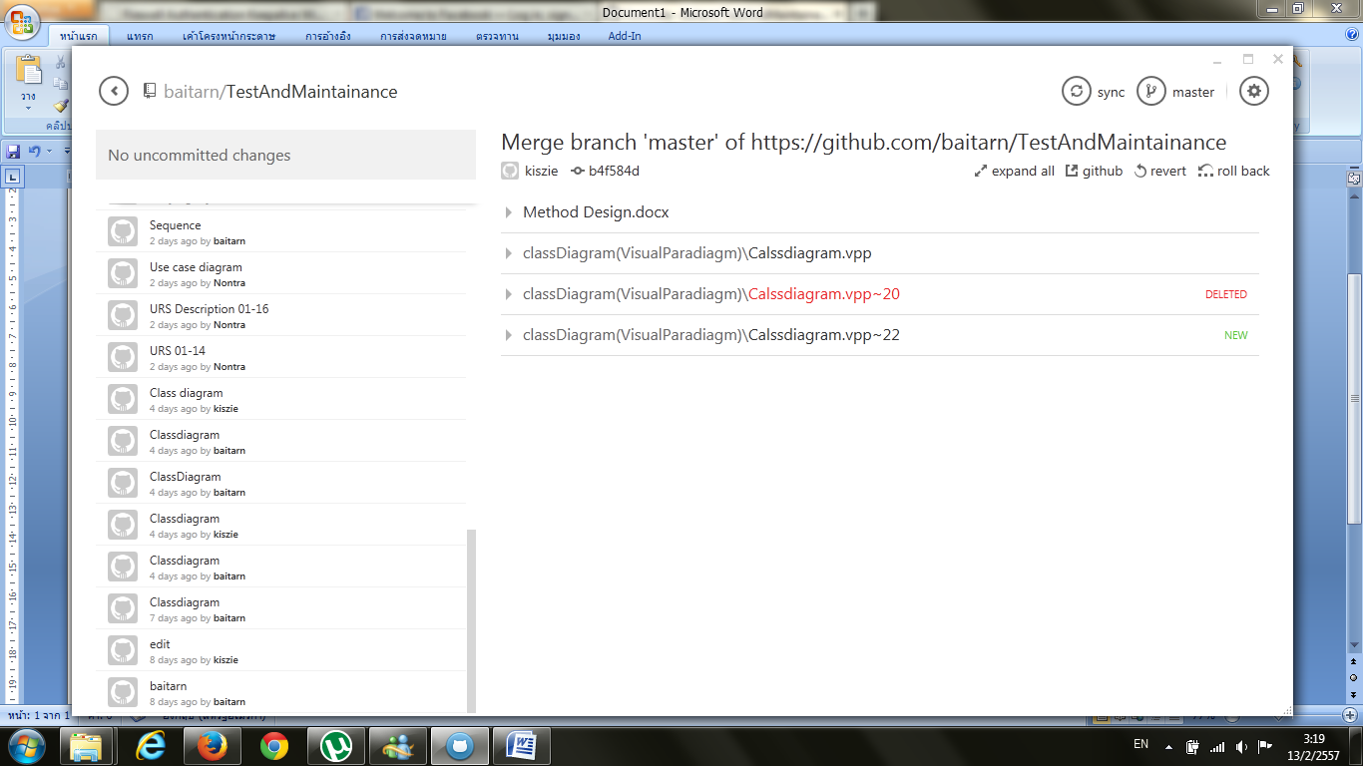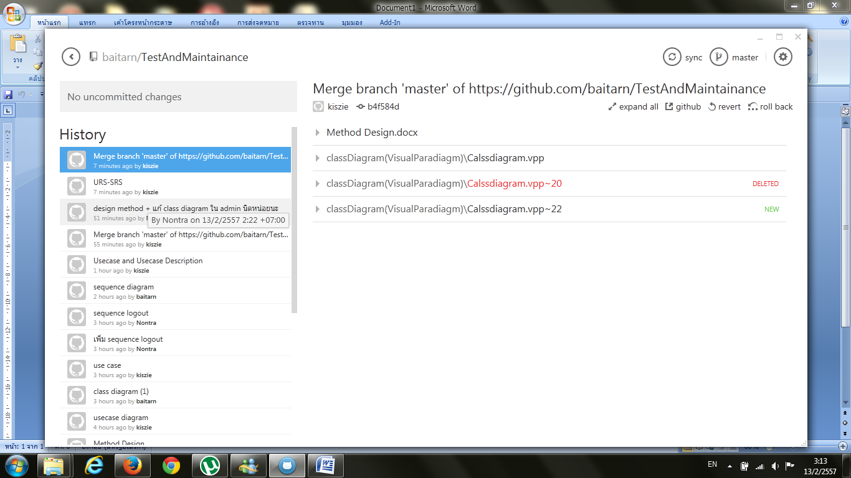**Version Control**

